# **Artificial Intelligence Foundations: Machine Learning**

# 

### **Welcome**

Selecting transcript lines in this section will navigate to timestamp in the video

- Machine learning is one of the most active areas in artificial intelligence. That's partly due to the explosion of big data, but it's also because of huge advances in machine learning algorithms. We now have machines that can learn to drive cars, search for new pharmaceuticals, and even be expert players in games that require complex strategy and creativity. These abilities are just the beginning. Machines are getting better at tasks that, in the past, could only be accomplished by humans. Machines are learning how to make better judgments through pattern matching and strategic decision-making. This course will give you a high-level overview of machine learning concepts and technology. You'll see how machines learn, then you'll see some of the most widely used machine learning algorithms. Finally, you'll get some ideas on how to select the best algorithm. Many organizations are taking advantage of this technology and say that one of the biggest obstacles is finding employees that are knowledgeable about machine learning. This isn't just for data scientists, but also for managers, and even executives who could benefit from knowing more about this technology. That's why this course is designed for mangers, entrepreneurs, students, or professionals who want to better understand machine learning. You'll see how machine learning fits into the overall world of artificial intelligence, then you'll see how to harness this new technology to make better decisions and find patterns in your data. So let's see what those machines have been up to in the world of machine learning.

### **What it means to learn**

Selecting transcript lines in this section will navigate to timestamp in the video

- Machine learning has been around for a long time. You can probably tell because the term itself is a little old fashioned. You don't often hear computers referred to as machines. The term machine learning got its start in 1959, when computer pioneer Arthur Samuel wondered if computers could learn their behavior instead of being programmed to do specific tasks. This type of thinking was drastically different from how most computer scientists viewed computers. A computer needed to be told exactly what to do. Think about how you interact with computers. Most programs are a series of explicit instructions. That's why when you're creating software for something like a banking application, you need to be very precise. You might create an instruction that says something like, "If a customer tries to withdraw money "and that exceeds their balance, "then cancel the transaction." That's an explicit instruction. If you see X, then do Y. Machine learning is different. Here you're not creating detailed instructions. Instead, you're giving the computer the data and tools it needs to study the problem and solve it without being told what to do. Then you're giving the computer the ability to remember what it did so it can adapt, evolve, and learn. That's not that much different from how humans learn. Several years ago I decided to purchase a new bookshelf with my wife, and we picked out a fairly large one from IKEA. Soon after I opened the box, I realized that putting it together would be incredibly difficult. I knew I'd have to learn by doing and I'd make a lot of mistakes. The instructions said that each one of the shelves had to have something called a dowel on each side, so I put dowels into each of the holes. Then I shoved the shelf into the sides and waited for feedback. My wife pushed down on the shelf and we were both surprised to see that it worked. Once I figured out the first shelf, I had enough experience to install the other shelves. That way I didn't have to look at the instructions each time I installed a new shelf. This human learning was about starting small and then going big. I had a problem so I formed a rule based on my own experience. I then used the rule to try some larger action. Then I waited for feedback to see if I needed to adjust the rule or leave it as it is. Each time I learned a new rule that worked, I added it to my memory. Once I finished, I probably could have put together many different types of IKEA furniture. In machine learning, computers go about this in much the same way. The machine starts by testing something smaller like some smaller part of the data. Then it uses a statistical algorithm to see how the data fits together. As a human, I had a rule that my shelf needed a dowel. A machine might have an algorithm that says two types of data should be treated the same way. The machine will then use the algorithm to look for patterns. The machine will then get some feedback. Remember that we tested the shelf by pushing down to see if it would support the book. Here the machine might test their outcome against their training data to see if it was correct. Anytime the machine learns something new, it adds it to the database. In a sense, it's storing it in its long-term memory so it can improve and adapt. Keep in mind that the machine and the human both came away with added expertise. I learned how to put together a needlessly complex bookshelf, so now I'd know much more about furniture assembly and our machine would know much more about the data.

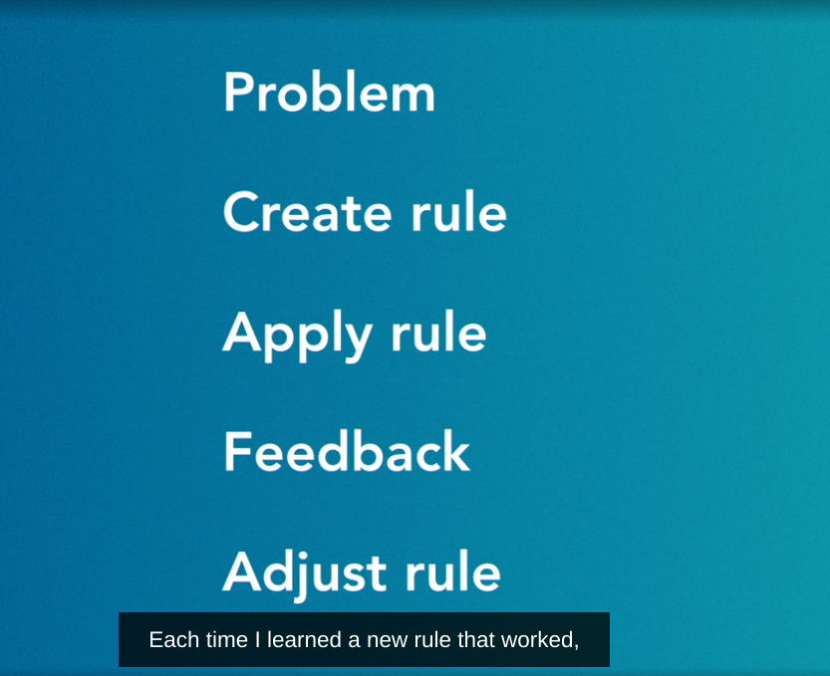

### **Work with data**

Selecting transcript lines in this section will navigate to timestamp in the video

- Much of computer science is still about working with explicit instructions. In traditional programming, you configure the machine to accept your input and produce an output based on the algorithm. The input is the command and the output is a predetermined response. That will work well when you have a program with straightforward calculations. But it gets a little trickier when humans can't explicitly instruct the computer on what to do. In these cases you need a programming model that allows the machine to learn. You also have to give the machine some ability to respond to feedback. This is a perfect scenario for machine learning. Imagine you're creating a program that needs to detect spam messages. These messages are usually filled with unwanted advertisements or even viruses. You can easily create a word filter program that deletes messages with common spam words so you can filter words like gold, lottery, or winner. This would certainly delete a lot of spam messages, but it would be pretty easy to spoof. You can change the word lottery to contain zeros or just use images. It also might lead to a lot of false positives. Maybe your friend sent you a joke about winning the lottery. This email would accidentally get deleted. These types of challenges don't work well when you're limited to carefully defined instructions. You can't simply create an input command with a predetermined response. That's why machine learning switches things around. Instead of inputting instructions, you'll input data. Instead of a predefined response, you'll be working with machine learning algorithms to help the machine learn how to respond. To start, you'd want to split your data into test data and training data. The training data is a smaller chunk that you'll use to find patterns. Sometimes a model will help your machine make sense of the data with statistical algorithms. These algorithms help the machine make accurate predictions or see patterns between different parts of your data. Let's think about how machine learning might work with our spam program. Let's take 10,000 email messages as our training dataset. We'll use it to build and refine our model before we try it on our test data of over a million messages. You can use your test data to show the machine different examples of spam. Then you could use a classifier machine learning algorithm to help split the email in the two groups. You could have your spam, then a regular message. This is often called binary classification. The machine does this by finding groups of words that are more likely to be found in spam messages. Then it comes up with a score to show the likelihood that it's spam. As a machine learning expert, you'll need to decide the best classifier algorithm to use. Then you'll tweak the hyper-parameters of the algorithm until the machine does a pretty good job predicting whether or not an email message is spam. Once you're satisfied, then that'll be your initial data model. You'll use a machine learning algorithm and tune the necessary hyper-parameters to make an accurate prediction. The key thing to remember is that even though the programmer inputs the data, selects the algorithms, and makes corrections, it's ultimately the machine that makes the decision about whether a message is spam. In some cases the programmer might not even know how the machine learned it was spam.

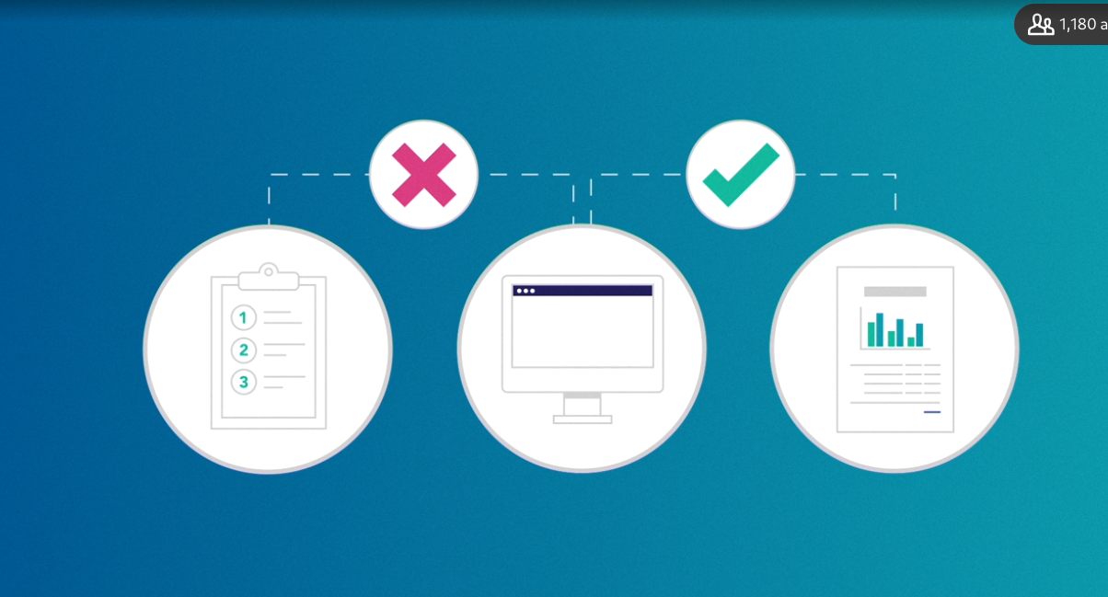

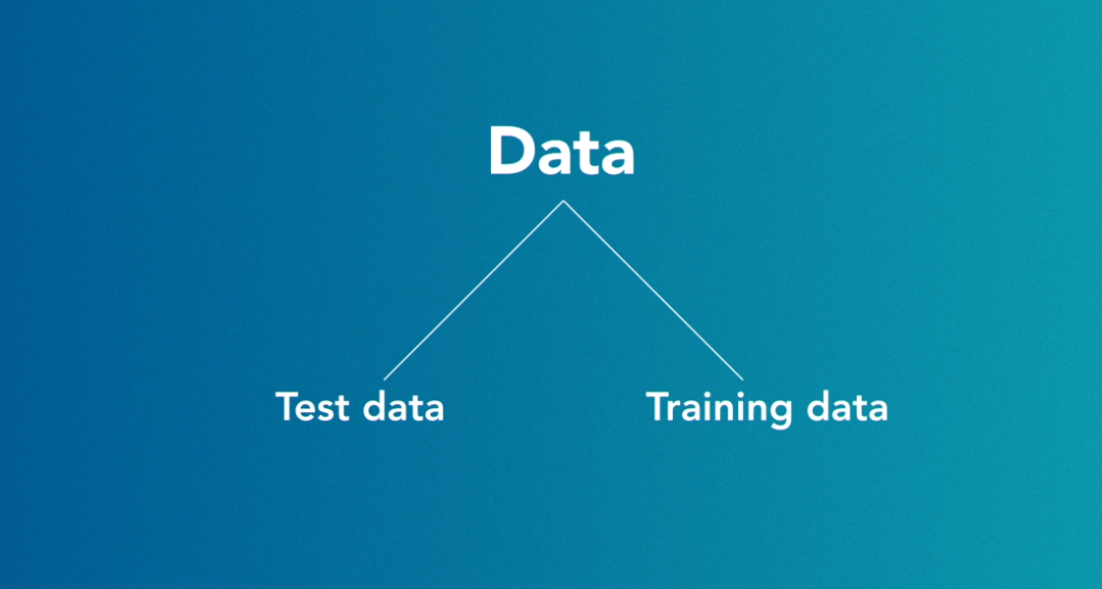

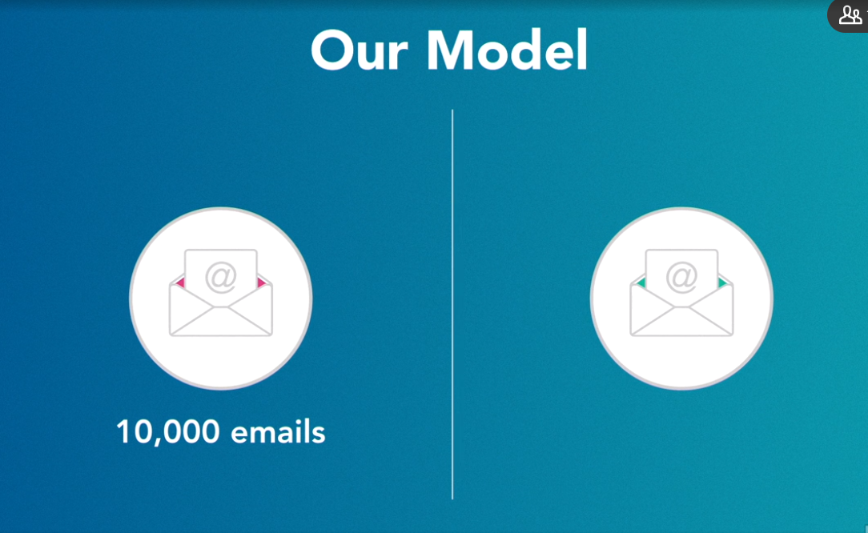

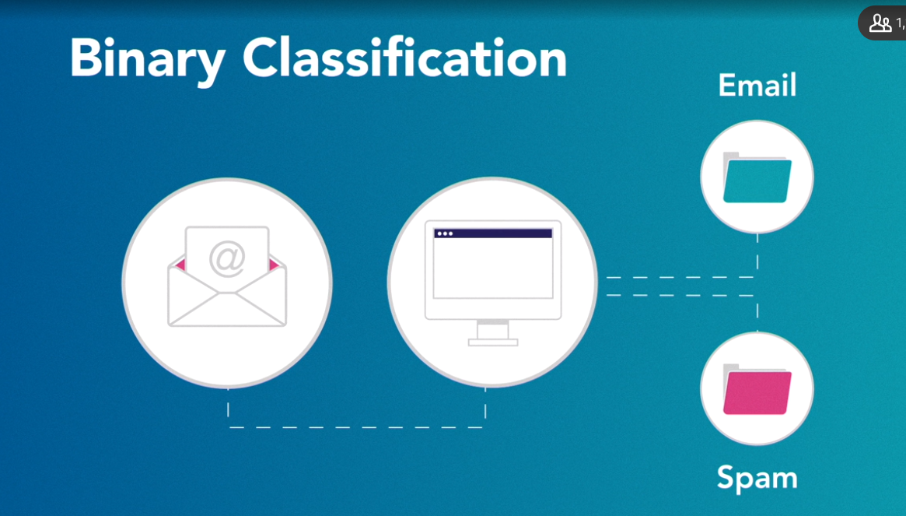

### **Apply machine learning**

Selecting transcript lines in this section will navigate to timestamp in the video

- Machine learning is already used in many different industries. When you check the weather, or if you're typing something into a search engine, you're already benefiting from machine learning. Any organization that has a lot of data and is looking for better ways to understand it can benefit from this technology. But there are some areas that are a much simpler fit. Think about this web application. Right now, you're either watching this video on a mobile device or on your computer. Machine learning can help us learn how to improve your experience. This application can collect a huge amount of data. So when you click on different videos, it can record what you're watching, where you are, and the time of day. It's pretty easy to collect massive amounts of data. What's difficult is gaining insights from that data. Machine learning can help take all that data and learn more about you. You could see videos that are much more relevant to what you'd like to learn. Maybe when you search for something new, you could have a customized search based on your interests. This application can study your behavior and see how it can better meet your needs. It might seem strange, but computers getting to know you better has actually turned into some of the most lucrative businesses. Companies like Google, Facebook, Apple, and LinkedIn are all using machine learning to better understand you. Some companies are even pushing the envelope of privacy by looking through your previous searches or trying to better understand your friends. That way, every time you use their service, they can give you a customized experience. That's why your Facebook newsfeed is unique to you. It's also why two people putting in the exact same search term into Google might get completely different results. Any time you're on a website and you see something that says Recommended For You, then you're probably benefiting from machine learning. Amazon looks through all of your previous purchases and then uses machine learning algorithms to recommend items. Netflix uses machine learning to find complex patterns so it can recommend different shows based on what you've already watched. YouTube lines up the next video based on those that you've watched in the past. They do this as a way to better make recommendations for you. Many organizations are using machine learning for automatic translation. YouTube might use natural language processing to transcribe your video and make subtitles. They're translating your speech into text. Some sites will use machine learning to translate one set of subtitles into several different languages. In machine learning, you're using artificial intelligence to help your program find patterns in massive data sets. Often, they find patterns in data that humans could never see. That's one of the most interesting things about machine learning, it's not just an enhanced form of human learning. Instead, it's a completely different way to find patterns, make decisions, and gain greater insights. So if you want to use machine learning in your organization, you have to think about the way the machine learns. That way, you can start to collect the data that will allow your program to better understand your customer. Before you start your machine learning project, you have to think about your data. Is it of high quality? Do you have enough data to learn something new? Remember that this is the way your machine learning program will view the world. The broader the view, the more likely it is you'll find something interesting. You don't want your program looking through a keyhole. When planning to use machine learning, start thinking about the best strategies to get high quality and diverse data sets.

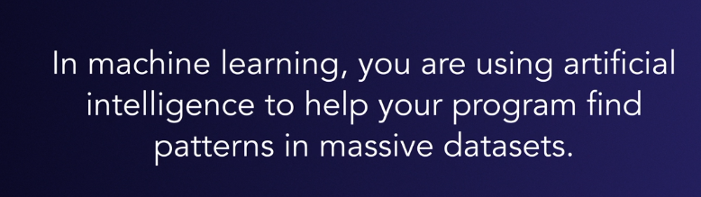

### **Different types of machine learning**

Selecting transcript lines in this section will navigate to timestamp in the video

- You may think of machine learning as a different name for something that's already around. Maybe it's just an updated way to describe statistics, or a new way to talk about data science. But the key when you think about machine learning is the focus on the term learning. Machine learning certainly has statistics. It might also be a key part of your data science efforts. But these are just the tools your machine needs to learn, they're not a substitute for learning. Think about what it means to learn. What are the different strategies that you use to learn something new? How can you take these strategies and then apply them to machines? Imagine you wanted to learn how to play chess. You could do this a couple of different ways. You could hire a chess tutor. They would introduce you to some of the different chess pieces and how they move across the board. You could practice by playing against your tutor and they would supervise your moves, and help you when you've made a mistake. Then, after a while, your tutor would finish all your lessons and you'd start to play competitively with others. Let's say you couldn't find a tutor. Then you could go to public parks and watch several hundred experts play the game. You couldn't ask them questions, you'd just quietly watch and learn. If you do this long enough, you'd probably understand the game. You might not know the names of the chess pieces, but you could understand the moves and strategies from your hours of observations. You might even try a combination of these two approaches. A chess tutor would show you the basic rules, then you'd go back to watch other people playing. You'd have a high-level overview and the names of the chess pieces, but you'd rely on observations as the way to see the new strategies and improve. These three strategies are very similar to how a machine might learn. You could do something called supervised learning. Here, a data scientist acts like a tutor for the machine. They train the machine by showing it basic rules and giving it an overall strategy. You could also try unsupervised learning. Here, you just have the machine make all the observations on its own. The machine might not know all the different names and labels, but they'll find patterns on their own. Finally, you could mix the two and try semi-supervised learning. Here, you would train the machine just a little bit so they get a high-level overview. Then most of the learning about the rules and strategies is through observing different patterns. As you can imagine, all three approaches have their own strengths and weaknesses. For supervised learning, you'll need a knowledgeable tutor. There needs to be someone out there that knows a lot about chess and could show you how to play the game. With unsupervised learning, you need to have access to a lot of data. You might not be able to go to a public park and watch hundreds of different experts play the game. It also depends a little bit on who you watch. You need to watch people who are playing well. With semi-supervised learning, you can run into trouble on both sides. If you have a bad tutor, it will be much more difficult to learn through observations. On the other hand, if you have a great tutor, but the people you observe are poor players, then you might understand the game, but not really become a master player. You might be in a position where you can decide which approach works best. But, often, you just have to do the best with what's available. If you can't find a tutor, then you have to do your best by observing people in public parks. If you don't have a public park, then you have to do your best to find a good tutor. You can only do semi-supervised learning if you have access to both.

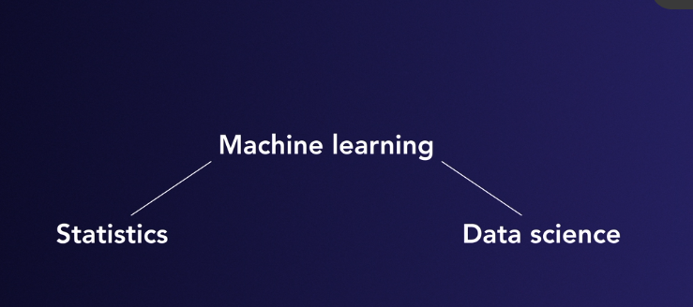

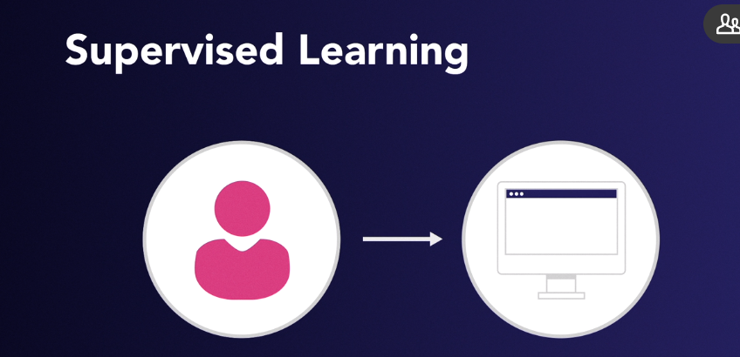

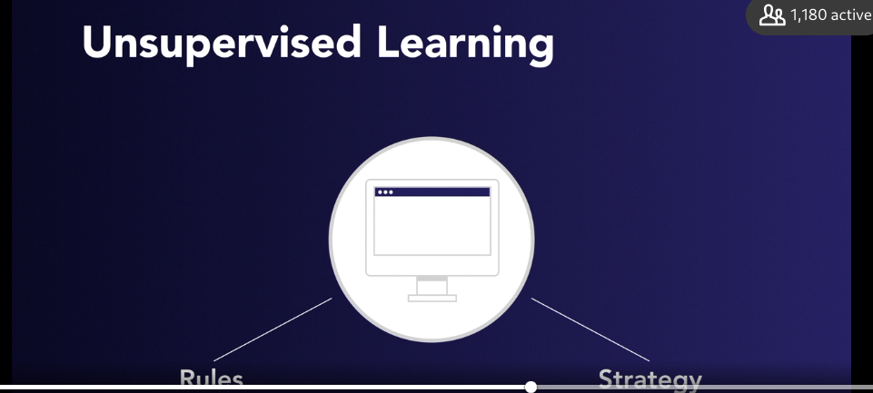

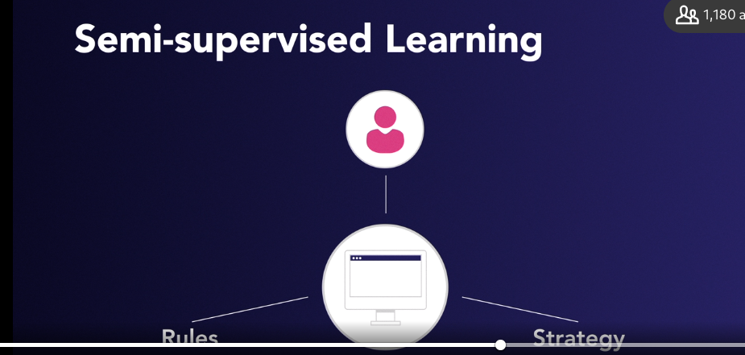

## **Question 1 of 4**

Drithi has formal badminton lessons every Tuesday afternoon, and plays with whoever is available on Saturdays. Which type of learning is she using?

* semi-supervised  
  Correct  
  Drithi learns rules by instruction on Tuesdays, and can then explore them on Saturdays.
* unsupervised
* supervised  
  Incorrect  
  Drithi's sessions on Saturdays are not supervised.

## **Question 2 of 4**

In the learning process, what would you typically do after implementing a rule?

* Practice training.
* Sort and edit data.
* Look for patterns.
* Observe feedback.  
  Correct  
  This corresponds to testing in a machine-learning process.

## **Question 3 of 4**

Which sort of problem is most explicitly amenable to a solution by machine learning?

* building a new antiviral drug  
  Incorrect  
  Parts of the process with a lot of data are amenable to machine learning.
* analyzing menu selection preferences  
  Correct  
  Looking for patterns in large datasets is the main strength of machine learning.
* designing a crash avoidance system
* writing a new algorithm for data analysis

## **Question 4 of 4**

Instead of explicit, stepwise instructions, what are the fundamental inputs to a machine-learning process?

* hyperparameters
* classifications
* data  
  Correct  
  A machine learns from data, information, or experience.
* clusters

### 

### 

### **Supervised**

Selecting transcript lines in this section will navigate to timestamp in the video

- When you know enough about your data, you can help your machine connect the dots with supervised learning. In supervised learning, you show the machine the connection between different variables and known outcomes. In machine learning, this is called the labeled sample data and the correct output. It's called labeled data because it's already tagged with identifying information. Imagine you wanted to train a machine to help you predict how long it will take you to drive home. You would start by creating a set of labeled data. This data would include weather conditions, time of day, and whether it's a holiday. These are your inputs. The output would be the amount of time it took to drive home on that particular day. In this case, your independent variables would be the input and your dependent variable would be the output. Here you want to use different machine learning algorithms to map the relationships between these different variables. You can use statistical regression for this and determine how the independent variables affect the dependent variable. You intuitively know that if it's raining outside, it will take you longer to drive home, but machines have to rely on data and statistics. They have to look at the length of your commute and compare it to labeled data it has on the weather. Let's see how we can create a supervised machine learning model to help us determine our commute time. The first thing you want to do is create a training set. Based on this training set, your machine might see there's a direct relationship between the amount of rain and the time it takes to get home. The more it rains, the longer you'll be on the road. It might also see there's a connection between the time you leave work and the time you'll be on the road. The closer you are to 5 p.m., the longer it takes for you to get home. Your machine finds some of the relationships with your labeled data. This is the start of your data model it begins to understand concepts like how rain impacts the way people drive. It also starts to see that there are more people who travel during certain times of day. Then your machine takes this training set and applies it to a test set of your data. It looks to see if the model in this training set holds true when you're looking at many more days. You could ask the computer to predict how long it will take you to drive home each day and then give it feedback on how accurate it was in its prediction. Over time, the machine will learn and adapt its model to improve the output. Your machine will continue to tune the model in the training set and you can make adjustments based on the new data. This is pretty similar to how humans learn. Think about when you learned how to drive. You started in a small parking lot with an adult guiding you. Then you got to the point where you could drive predictably and safely in this smaller space. Then once you built up enough confidence, you'd head out into the open road. You won't learn everything you need to know about driving in the parking lot but you should get enough data to help you get started. Chances are you'll still learn a lot of new skills, and hopefully you'll continue to improve over time until you become an expert driver. The key thing to remember is that in supervised machine learning you know a lot more about the training data. You can feed labeled data into the machine that's easily classified. So with your commute home you know more about the weather, holidays, and time of day. This labeled data is the key difference between supervised learning and other forms of machine learning.

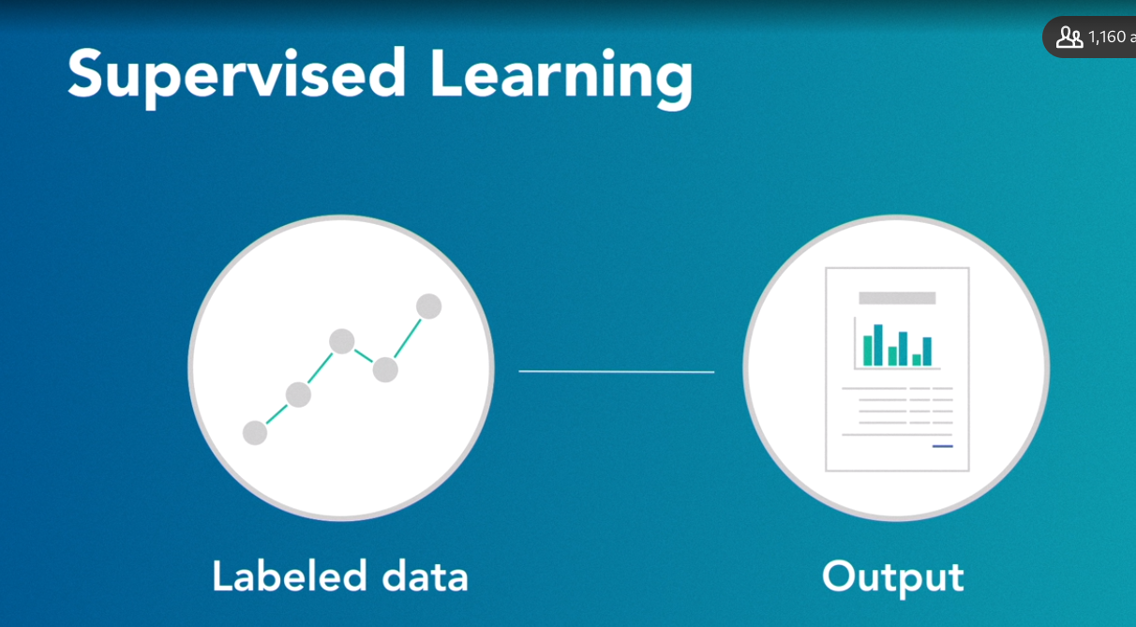

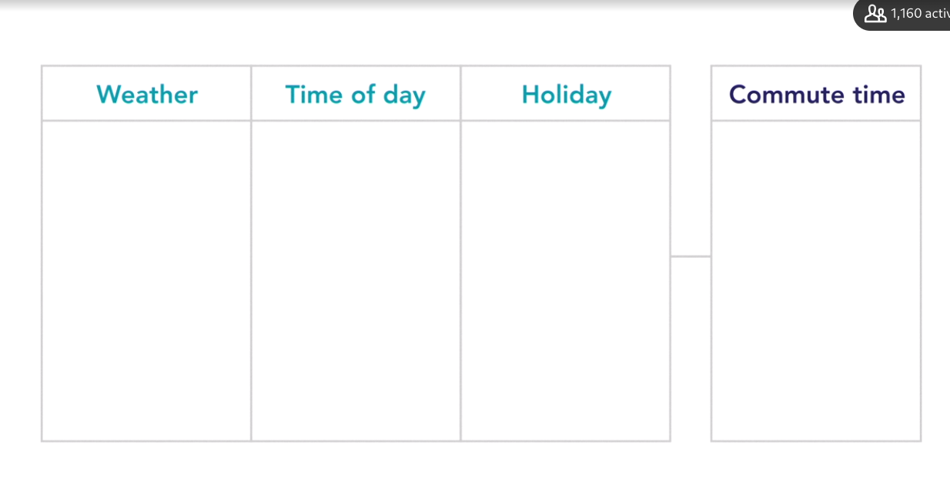

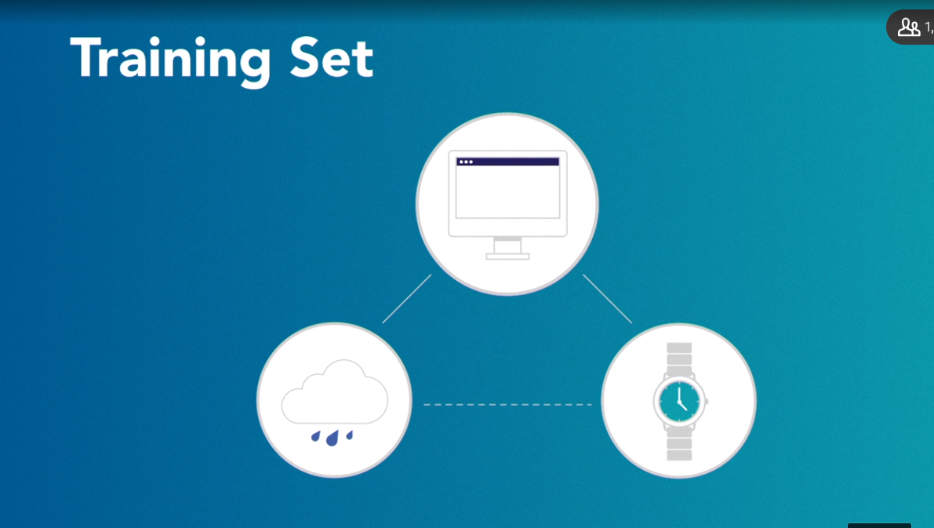

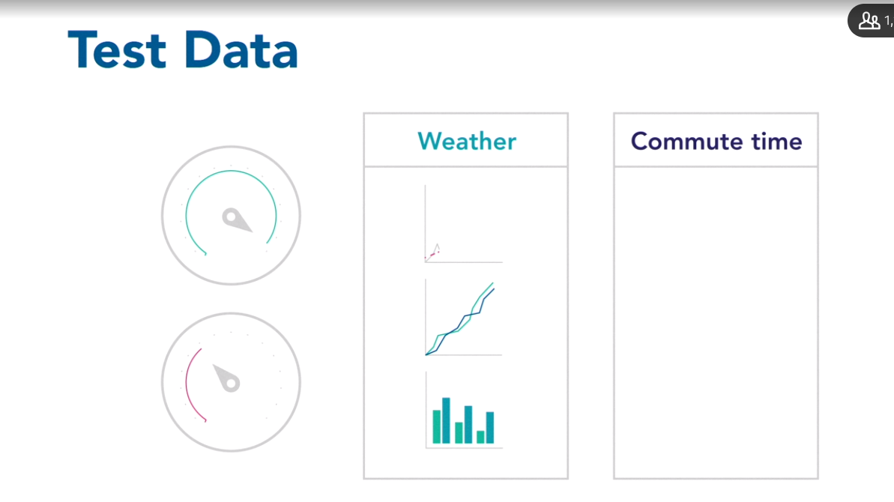

### **Unsupervised**

Selecting transcript lines in this section will navigate to timestamp in the video

- Unsupervised learning might seem the most familiar. If you think about it, you weren't actually taught many of the things you already know. You weren't actually taught how to walk or how to clap your hands. Instead, you learn much of this through study and observation. Learning and improving by trial and error is the key to unsupervised learning. Unlike supervised learning, you're not working with labeled data, you're not showing the machine the correct answer. Instead, you're using different algorithms to let the machine create connections by studying and observing the data. Think of it this way. Every Halloween, the past few years, my son has done something called trick or treating. All the kids in the neighborhood go door to door and ask for candy. At the end, he comes home with a bag of hundreds of different little pieces of candy. The first thing he wants to do is classify the candy by what he likes the best. In machine learning, this is called multiclass classification. There are several different groups into which you want to classify your data. Now, in the past, my son has benefited from my experience. I've been able to supervise his learning. I can help create output categories for the candy, such as chocolate, peanut butter, mints, and gummies. I've even shown him some of the tags and labels for his data set. Mints are almost always small and they smell like toothpaste. Peanut butter candies tend to look like little chocolate muffins. Fruit chews almost always have yellow or orange packaging. Then I can create a small training set where I pull a few of his candies into separate little groups. Then he can classify some of the unknown candies into these different categories. After I leave the room, I can hear him saying, mint, chocolate, mint, fruit chew, as he classifies the rest of the bag. Now, my son also has grandparents that live in a different country. They feel bad that they can't participate in this tradition. So each year, they send my son a large bag of local candy that they've collected all year. With this bag, we can't use a form of supervised learning, because it's unlabeled data. Neither he nor I have ever seen the candy before and the wrappers are in a language we can't understand. So in this case, we do a form of unsupervised learning. He looks at the bag and creates his own way of clustering the candy. He does this based on his own study of the data and observations. There might be a group based on the size or the color of the wrapping. In fact, one year, he created a grouping that I'd never considered. It was a small cluster that he called perfume candy. It was candies that were made out of flower blossoms. This is a key part of unsupervised learning. Like my son, the machine studies the data and comes up with its own observations. In this case, it was all about clustering the candy into these groups. But you can also use this technique to create connections or even find something new. You might see drug companies use this technique to try and find chemicals that might behave like an antibiotic. They could use supervised learning. They'd show the machine a small training set where they'd label certain chemicals antibiotics, but they also might stand a better chance of finding something new if they try unsupervised learning. They could have the machine study and observe millions of different chemicals. Then they could have the machine create their own clusters. Maybe they'll find a cluster with many known antibiotics. As you can imagine, one of the key things with unsupervised learning is access to massive amounts of data. The more data you have, the easier it is for the machine to observe and study trends that might lead to a worthwhile cluster.

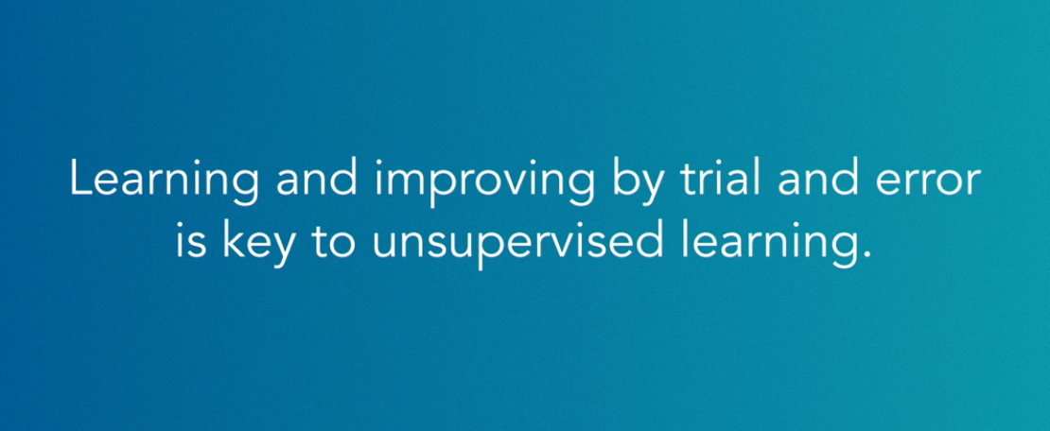

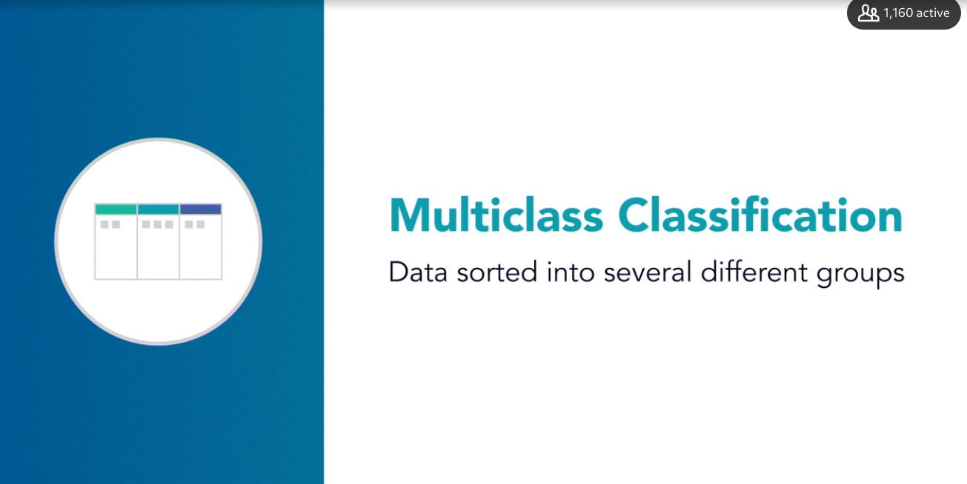

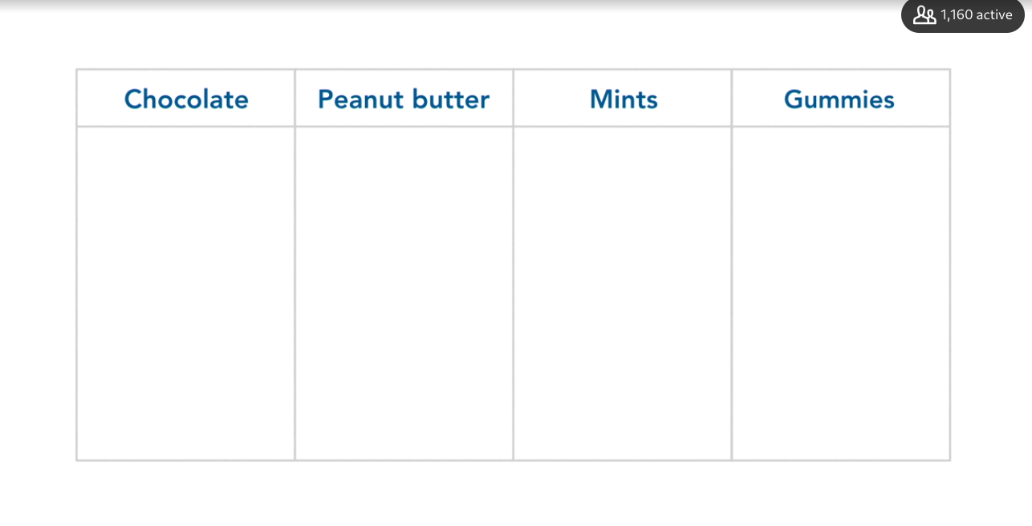

### **Semi-supervised**

Selecting transcript lines in this section will navigate to timestamp in the video

- Semi-supervised learning is a crossover that takes advantage of both supervised and unsupervised learning. Imagine you wanted to create a program that could translate voicemail into text. It would be difficult to use unsupervised learning. Here, your machine would cluster words together but wouldn't necessarily know what those words mean. Maybe your machine could identify each time someone said the word photo. The problem is that, since it's clustered and unclassified, your program doesn't know that this sound for photo is the same thing as the word for photo. On the flip side, you wouldn't want to only use supervised learning. It would be far too labor-intensive to label all of the data for words and their sound. Plus, you could never create a training set that was large enough to translate all your possible words and phrases. So, instead, you might try semi-supervised learning. Here, you'll start with a smaller training set of very common words and phrases. The machine could use this to perform some basic classification. This would be like the training set in supervised learning. But then you would feed that training set into the machine and allow it to study and observe the rest of the data. This is similar to unsupervised learning. That would allow the machine to expand its vocabulary based on what it already classified. With the labeled data, the program could use a form of inductive reasoning to try and expand its own vocabulary. It might use the training data that connects the word photo to the sound photo and come up with new translations. Maybe it can induce the word photograph, photographer, photocopy, or even photon torpedo. It will have the training data for the word photo and the sound photo, and so the machine would just use inductive reasoning when making the translations. Each time the machine induces a new connection, it does its best to try and improve the model. So if the translation is correct, it will add all of these words. You usually get this feedback from human observers. That's why when you get a translation, you'll often see a link that says, how is this translation? But inductive learning is not the only form of semi-supervised learning. There's another form of semi-supervised learning called transductive reasoning. This allows you to narrow down the unlabeled data by thinking about what you already know about the collection. So if you were using transductive reasoning to transcribe the voicemail, you'd have to think about the data in a larger context. Think about some of the things that people say in a voicemail message. People probably put many more nouns in their voicemail messages. They're giving you information about people, places, or things. They're more likely to talk about times and dates. A typical voicemail message might be something like, hi, this is Jeff. I was calling to confirm our meeting next Tuesday. Give me a call if there's a change. This is much different from a random sampling of audio that you might get from listening to people in a restaurant. So transductive reasoning tries to improve the model by making better guesses about what's in the unlabeled data. Semi-supervised learning is not that common, but it works well in certain areas. It often works better when it's not difficult for the machine to create useful groups. But at the same time, the data is so large that it's not practical to use supervised learning. You might see semi-supervised learning used for classifying webpages, or grouping together pictures of something like insects. The key thing to remember is that semi-supervised learning really only makes sense when the other two approaches have difficulty solving your challenge. You might also keep in mind that inductive and transductive reasoning might lead to greater errors and mislabeled data. So try to think of them as the best solution for a particular problem and not necessarily the best place to start with your machine learning challenges.

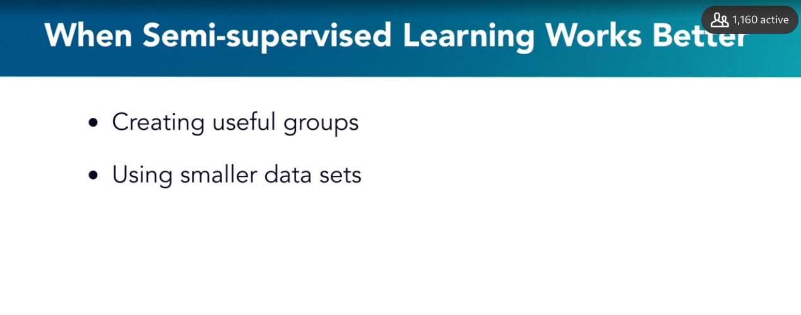

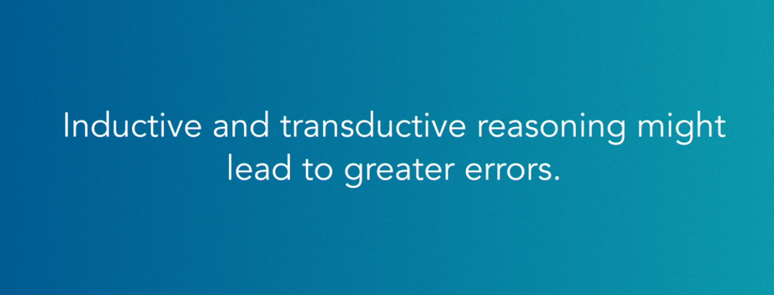

### **Reinforcement**

Selecting transcript lines in this section will navigate to timestamp in the video

- One type of machine learning has gotten a lot of attention over the last few years. It's called reinforcement learning. Reinforcement learning is different from supervised, unsupervised, and semi-supervised learning. With each of these techniques, you're trying to invent the best model. You want to find a model that can most accurately classify different data sets or find meaningful clusters. Once you have the model, you can then let the machine work with the rest of the data. Reinforcement learning has the machine iterate to continuously improve the outcome. Over time, the machine should zero in like a heat-seeking missile and get closer and closer to high quality output. Reinforcement learning is very open ended. You're reinforcing certain ways that you want the machine to behave. Instead of leaving everything open to study and observation, you're giving the machine a very clear goal. Think of it this way. Back when I was younger, there was a simple video game called Pong. The game had two separate bars on the opposite sides of the screen. They would slide up and down as you tried to hit the ball to each side. In 2013, Google's Deep Mind project experimented with Pong to see if they could teach a computer how to play. They set up a series of rewards for the computer. Every time the computer hit the ball against the paddle, it got a reward. Then every time that the opponent missed the ball, it got another reward. Then it played against itself and tried to gather as many rewards as possible. It only took a short while for the computer to start to master the game and consistently beat human players. The Deep Mind team used something called Q-learning. This Q-learning helped with some of the more complicated games that needed more sophisticated rewards. In Q-learning, there are set environments or states. There are also possible actions that can respond to these states. In Q-learning, you want the machine to improve the quality of the outcome. This is represented with the letter Q. You might have a game like Space Invaders that requires you to shoot through aliens to eventually win the game. This has a more complex reward system. It's not just as simple as having your opponent miss the ball. In this case, you would start out with a quality of zero. Then you would have the machine learn which actions improve the conditions. Each time an action improved the state, the Q would go up from zero. The Q would go up based on the states and actions. This type of reinforcement learning is one of the most promising areas in machine learning. It allows the machine to go through endless simulations of actions and states until it finds the best strategy. In 2015, Google's Deep Mind project made the news when their AlphaGo program first beat an expert player in the game called Go. AlphaGo used a form of unsupervised learning. It learned primarily by observing professionals playing the game. Their newer program AlphaGo Zero relies primarily on Q-learning. It didn't have to watch the experts play the game. AlphaGo Zero simply went through the game and tried different actions as a way to change the state and win. Within hours, this Q-learning machine played Go at a level that humans can't understand. In fact, after just 70 hours of training, AlphaGo Zero beat the earlier version of AlphaGo in the first 100 tries. Reinforcement learning and specifically Q-learning allows machines to quickly grow beyond our understanding. It can help you skip the steps required in unsupervised learning. You don't need hours of observing and studying massive amounts of data.

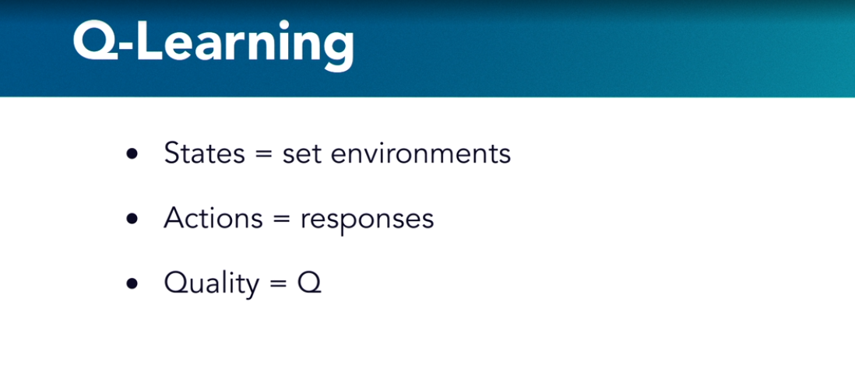

## **Question 1 of 5**

What distinguishes supervised machine learning from other types of machine learning?

* identifying fundamental rules
* classifying variables as dependent or independent  
  Incorrect  
  This is only part of the difference.
* using programming or instruction
* using labeled data for training  
  Correct  
  One has a lot of prior knowledge about the training data in supervised learning.

## **Question 2 of 5**

How are induction and transduction different?

* Transduction is more general or global than induction.
* Transduction uses more information and produces more specific rules.  
  Correct  
  The results of transduction are not as general.
* Induction is less risky than transduction.
* Induction requires more training or labeling than transduction.  
  Incorrect  
  Both induction and transduction make use of labeled data.

## **Question 3 of 5**

A company has a variety of efforts that it uses to find new antiviral medications. Which effort best exemplifies unsupervised learning?

* the screening of a large collection of botanical extracts **ok**
* the modification of existing antiviral compounds  
  Incorrect  
  This process uses a large amount of prior information.
* the design of a new molecule based on general rules  
  Incorrect  
  The use of rules indicates supervision, rather than an unsupervised process.

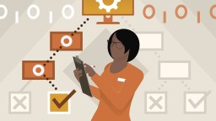

Replay

Review this video

Unsupervised

4m 13s

## **Question 4 of 5**

Why would you choose to not use semi-supervised learning all the time?

* It takes a large investment in labeling data.
* It prevents the use of any form of induction.
* It can lead to larger errors or confusion.  
  Correct  
  Transduction and induction can both be very misleading.
* It requires a vast amount of prior knowledge and training.

## **Question 5 of 5**

What does Q-learning use instead of training or testing data?

* heuristics
* simulation or experience  
  Correct  
  The quality is optimized by iteration.
* labeling and user intervention
* rigid rules

### **Problems that use machine learning**

Selecting transcript lines in this section will navigate to timestamp in the video

- In the HBO show Silicon Valley, one of the characters uses machine learning to go after a real problem. He uses a smartphone to take a picture of some food in front of him. Then the application tells him whether or not it's a hotdog. He helpfully named the application Not Hotdog. He created the application by building a small training set of hotdog pictures and then processing millions of different food pictures online. Essentially, he used supervised learning to do a form of binary classification. Even though there are many different supervised learning problems, they generally fall into a few categories. The first is a binary classification like Not Hotdog. Then, multiclass classification, and then finally, regression problems. Each of these problems generally uses the same type of machine learning algorithms. Not Hotdog used a statistical method to check the probability that the image on your phone contains a hotdog. This is called binary classification. It's one of the most popular machine learning challenges. With binary classification, there are generally only two possible outcomes. Generally, yes or no. Is the hotel room going to be booked next week? Will the stock market go up this afternoon? Does this picture contain a hotdog? They have a predefined right and wrong answer. All binary classification uses supervised learning. Remember that supervised learning depends on labeled data. That means that someone teaches the computer a little bit about the right and wrong answer. You have to have a developer at the beginning to set the criteria. You have to show the machine a picture with a hotdog. Another common machine learning problem is multiclass classification. This is a problem where there are almost limitless possible categories. For this, you might imagine an application that looks at an image of a food item and classifies it based on several predefined categories. Maybe it will have something like sandwich, drink, or baked goods. Then you would use a different set of statistical algorithms to try and put the data into these categories. You'll see some of these algorithms in later videos. Another very interesting area of machine learning is around regression problems. Unlike binary and multiclass classification, these problems tend to have a continuous solution. Here you look for trends instead of trying to classify data into different groups. Think about whether a hotel room will be booked or not booked. This is a binary classification because there are only two possible outcomes. That's useful, but what's really useful is knowing how many rooms are likely to be booked. Here there are no predefined outcomes. It's not a yes or no question. Instead, there are a range of possibilities that are more or less likely. You can use statistics to predict that range of 40 and 50 rooms will be available. Like binary classification, most regression uses a form of supervised learning. Again, you're going to want to show the machine what it means for a room to be empty or full. Then you'll use something called linear regression. These diagrams will show a trend line that can help you predict how many of your hotel rooms will fill up. You've seen that these three problems all have very similar types of machine learning algorithms. The next step is to see how all these different algorithms work and which ones might be the best for each challenge.

Classification >> binary

Classification >> multi class

Regression >> linear >>multi >> polynomial

### **Decision trees**

Selecting transcript lines in this section will navigate to timestamp in the video

- Decision trees can be used for binary classification challenges with supervised machine learning. Using this method, you can set up predictors and match them to some outcome. Decision trees are fun and they're management-friendly. You could show how the machine is making decisions by creating a graphical tree for your presentation. So let's imagine that we were creating a decision tree to predict whether or not someone is likely to go to the beach. We'll create three predictors. Let's create a predictor called Sky, which records weather as overcast, rainy, or sunny. Then let's create another predictor called Weekend. This predictor records whether or not it's a weekend. Finally, let's create a third predictor that's called Wind speed. This will record whether it's a windy day. So you'll have two options, high or low. Now let's create one outcome variable. We'll give it a name. Let's call it Yash goes to the beach. It's a binary classification problem. So there are only two possibilities. You'll classify whether Yash goes to the beach or doesn't go to the beach. So let's now create some training data based on some actual data that we've collected about Yash. We could put it in a simple table with four columns. The first three columns are the predictors and the last column is the outcome. You could see the first two rows of data in the training set. If it's a sunny day on the weekend, and there's low wind speed, then Yash will go to the beach. If it's rainy and on a weekday with high wind speed, then Yash won't go to the beach. This combination of predictors will create a different outcome. This is all well and good except it isn't really a decision tree. To create the tree, we have to take this data and split it based on our predictors. Let's choose the predictor Sky for our root node. You should think of the root node as the very trunk of the tree. We decide to use Sky as the root node predictor, but you can pick any of the predictors that you think makes the most sense. Now let's split out the next level of our tree. This is called the decision node. Here you'll see all of the options in our root node. So in this case, there are three options, Overcast, Rainy, or Sunny. It's at this level that you'll record your first set of outcomes. Now remember that we want a binary outcome. We just want a yes or no answer. Did Yash go or not go to the beach? In each of these decision nodes, you'll see the total number of possible outcomes in the training data. There are three scenarios where Yash goes to the beach and nine where he stays home. These different outcomes will let us break the decision node down into several different leaf nodes. This is the second set of predictors that are possible outcomes at the decision node. You might notice that there are no leaf nodes when the decision node is Rainy. That means that there are no outcomes where there's a rainy day and Yash still goes to the beach. You don't have to break down your decision tree any further since there's no other option. Once you create your decision trees, you want to have a clear path to a yes or no outcome. If you have trouble getting there, you might have too much entropy. This means that your tree is getting too messy and it's taking too long to get to a yes or no answer. You can see some entropy in the tree when you look at the decision node for Wind Speed. Here you can see that there were two times when Yash did not go to the beach with high wind and only one with low wind. So you're not really gaining any information here about whether or not Yash is going to go to the beach. To get rid of this entropy, you might have to split the data with a different predictor or maybe not even use Wind Speed as a predictor to classify whether Yash goes to the beach. When you look at this decision tree, you get a pretty good idea about Yash's behavior. That's one of the best things about decision trees. It's not too difficult for people who don't know much about machine learning to get an idea of the different decisions.

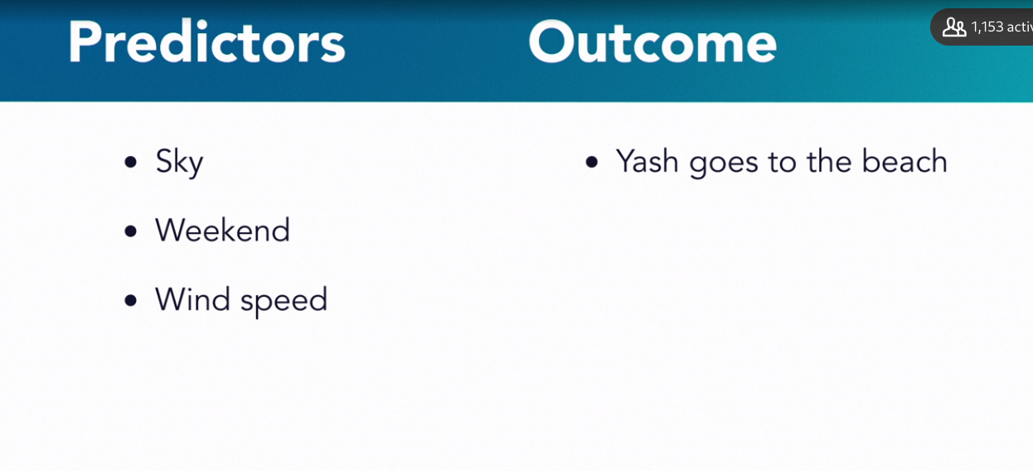

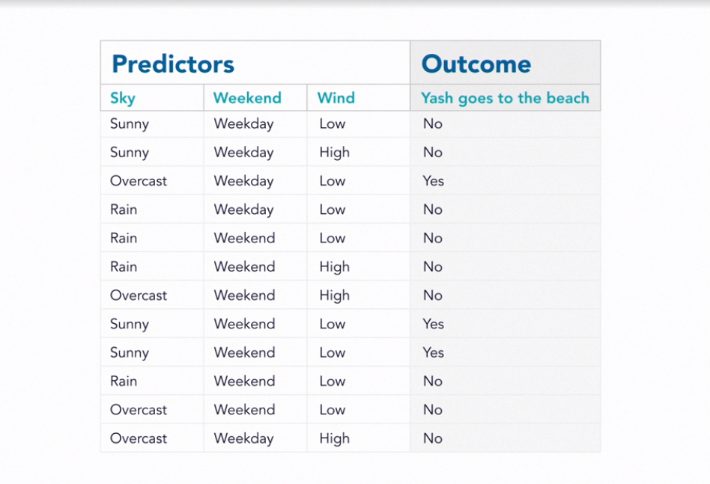

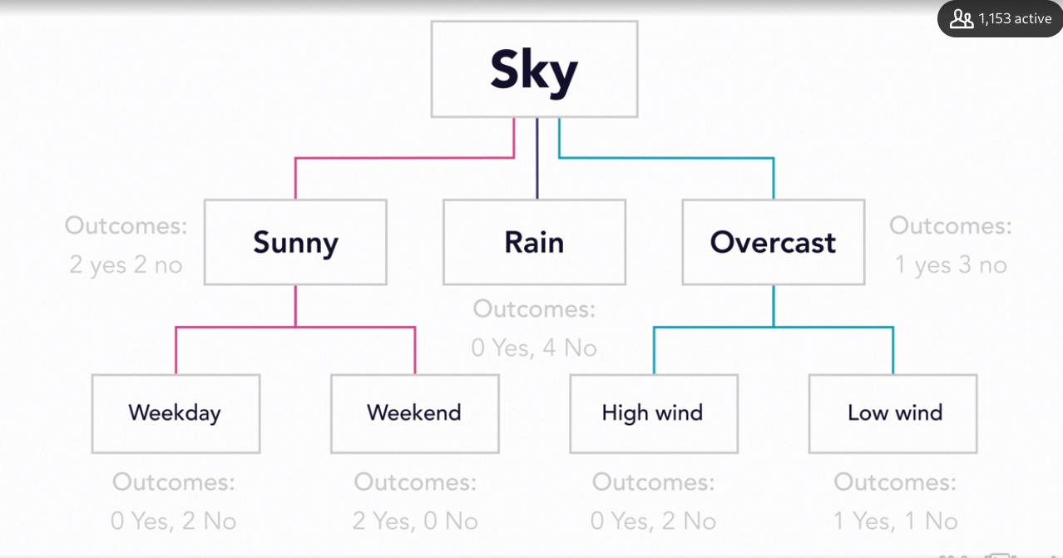

### **k-nearest neighbor**

Selecting transcript lines in this section will navigate to timestamp in the video

- In machine learning, one of the best ways to learn more about your data is by classifying it with what you already know. You can group together a bunch of data based on similar characteristics. Because you already know these characteristics, you can classify the data using supervised machine learning. A very common supervised machine learning algorithm for multiclass classification is k-Nearest Neighbor. This is an instance-based machine learning algorithm, or what's also called lazy learning. With lazy learning, the bulk of the computation happens right before you want to classify your data. The learning doesn't happen continuously. Instead, you run all your computation in one big instance. In a sense, you're saving up all your energy for one big splash. k-NN compares something you don't know to what you already have. So, in some ways, you're getting immediately rewarded for the size and quality of your training data. The downside is that this takes a lot of computational power, so sometimes it's difficult to use k-NN on very large data sets. Think of it this way. When I was younger, I used to work for an animal shelter in downtown Chicago. One of the most difficult jobs was trying to classify the breed of each new dog. There are hundreds of different known dog breeds. Not only that, the dogs aren't that close-minded about who they breed with, so you have a lot of mixed breeds. Each time we got a new dog, we would hold it up to several of the existing dogs that were already classified. Then we'd look at some of the characteristics. Maybe it was the shape of their face or the color of their hair. In a sense, the shelter was trying to classify the unknown dog by looking for its nearest neighbor. Of course, it's not really easy to tell whether a dog was a Boston Terrier or a French Bulldog. The closer the match, the more likely it was to be classified. Another way to look at it is you're trying to minimize the distance between the unknown dog and the known breeds. If the characteristics were closely matched, then there was a very short distance between the unknown dog and its nearest neighbor. Minimizing the distance is a key part of k-Nearest Neighbor. The closer you are to your nearest neighbors, the more likely you are to be accurate. The most common way to do this is through something called Euclidean distance. This is a pretty sophisticated mathematical formula that can help see the distance between your different data points. Now, imagine you had millions of dogs and you wanted to classify them based on their breed. To start out, we might want to create two key characteristics. These will help you classify dogs that share the same breed. These are often called predictors. So let's use their weight and the length of their hair. Now let's take these two characteristics and put them on an X-Y axis diagram. Let's put the length of their hair along the Y-axis and their weight along the X-axis. Let's take 1,000 classified dogs in our training set. We'll put them on the graph based on their weight and hair length. Now let's take our unknown dog and put it in the same chart. You can see that it's not matched with another dog, but it has a bunch of close neighbors. Let's say we use a K of five. That means we'd want to put a circle around our unclassified dog and its five closest neighbors. You can see that if the distance of the other dogs is shorter, you'll probably get a much more accurate classification. Now let's look at the five closest neighbors. You'll see that three of them are Shepherds and two of them are Huskies. You can be somewhat confident to classify your unknown dog as a Shepherd. There's also a reasonable chance that it's a Husky. k-Nearest Neighbor is a very common and powerful machine learning algorithm. That's because it can do more than just sort dogs. In fact, it's commonly used in finance to look for the best stocks and even predict future performance.

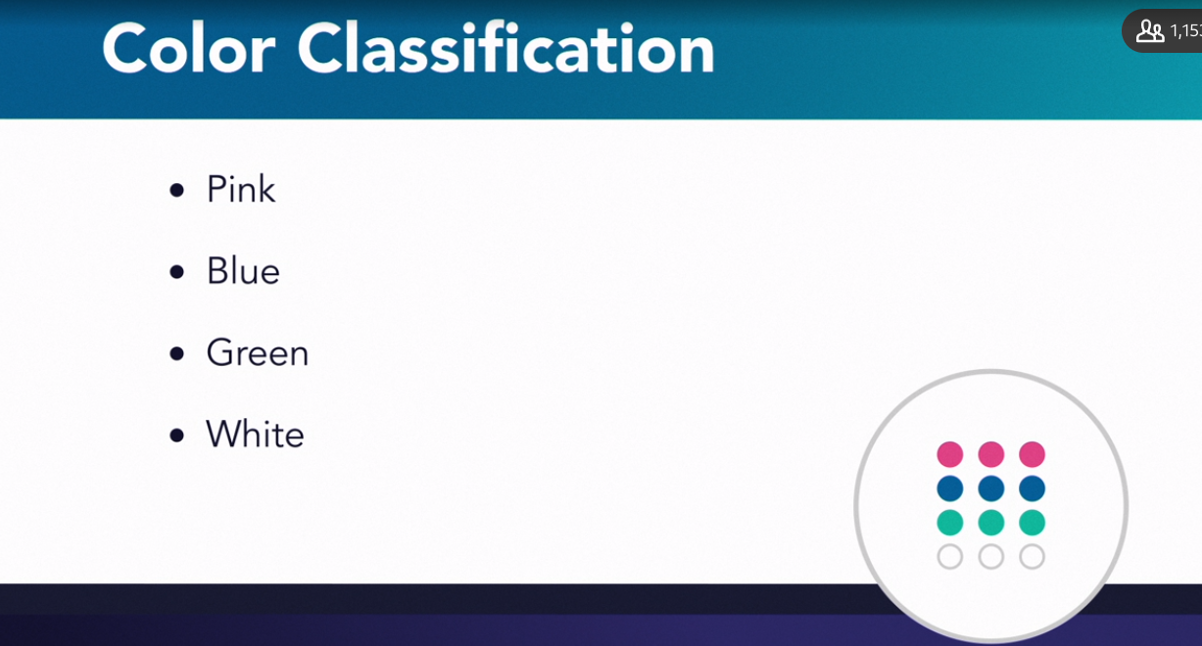

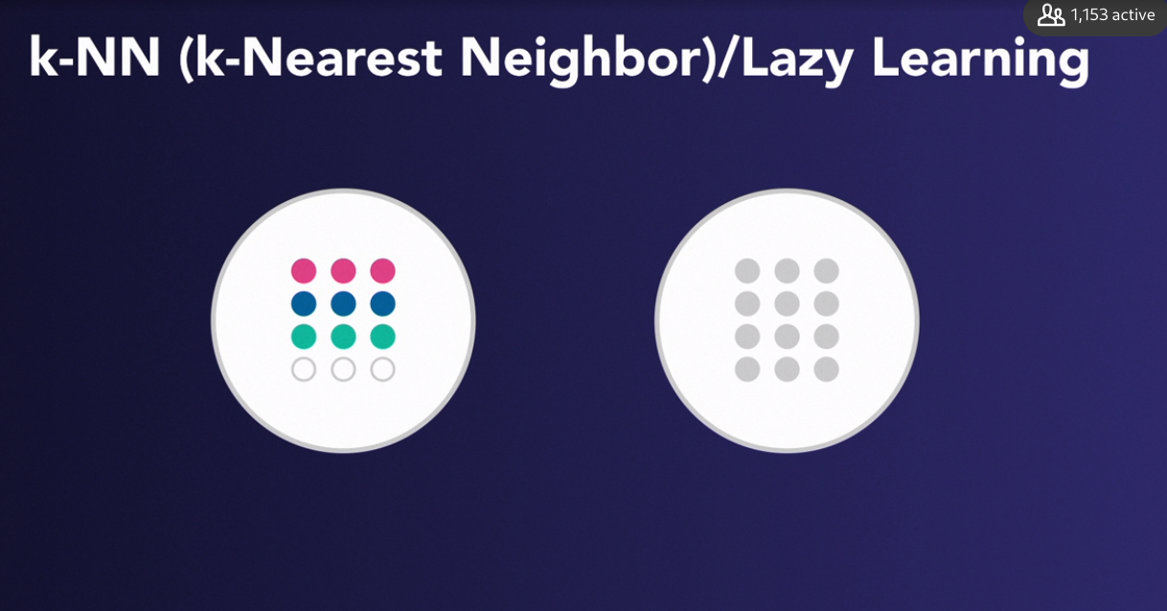

### **K-mean clustering**

Selecting transcript lines in this section will navigate to timestamp in the video

- Another common machine learning algorithm is k-Means Clustering. This algorithm is often confused with k-nearest neighbor or k-NN, but the only thing they have in common is that they both start with the letter K. Remember that k-nearest neighbor is a supervised machine learning algorithm. You're classifying data based on what you already know. On the other hand, k-means clustering is an unsupervised machine learning algorithm. You'll use it to create clusters based on what your machine sees in the data. Think of it this way. Imagine we're back at the animal shelter in Chicago. The shelter had a large social room where all the dogs get together and play. The dogs acted like people. They had their group of friends and they chatted and hung out with each other. Each time they had a social hour, they would self-organize into different groups of friends. Now imagine that the shelter was closing and all the dogs were going to be distributed into three different shelters across the city. The organizers of the animal shelter got together and decided to make it easier on the dogs, they would cluster them based on these groups of friends. So the shelter decided to create three clusters. That means that the k in k-means equaled three because you want to divide the groups into three clusters. Now imagine that the machine learning algorithm got started. To start, the machine put a red, yellow, and blue color on three random dogs. Each color represented a potential cluster based on their social group. These will be your three centroid dogs. Now each of the centroid dogs would look at the mean distance between itself and all of the surrounding dogs. Then the machine would put the same color collar on the dogs that were closest to these centroid dogs. As you can imagine since these centroid dogs were selected randomly, there's a pretty good chance that you won't really have any good clusters. Maybe all three centroid dogs were in the same social group. If that happens then most of the dogs would have a very large distance between these three centroids. So the machine will try over and over again until it picks the best centroid dog. It might even do this one cluster at a time. At the end of each iteration, the machine learning algorithm checks the variance between each dog and the centroid. Once you have a good centroid dog then it's pretty straightforward to put unknown dogs into each cluster. If you put a new dog into the social area then you can tell which social group it ends up in by just measuring the distance from the centroid dog. Also keep in mind that the dogs themselves did not cluster into three groups. There might be five or six different social groups, but there are only three shelters so the machine learning algorithm has to do its best to create clusters that best represent the dogs' social grouping. You should also watch to make sure that you use k-means clustering if the dogs are predisposed to these social groups. If the dogs are jumping from group to group then it'll be difficult to form real clusters. This is sometimes called a high overlap of data. Another challenge with k-means is it can be very sensitive to outliers. So if you have a dog that's not really interested in hanging out with any of the other dogs, it will still be clustered into one of these three groups. So in a sense, the dog will be forced to find friends. Organizing dogs into three clusters for three different shelters is probably not a problem that you'll run into everyday, but k-means clustering is actually one of the most popular machine learning algorithms. One of the more interesting applications is when retailers use clustering to decide who gets promotions. They might create three clusters that they call loyal customers, somewhat loyal customers, and lowest priced shoppers. Then they'll create strategies to try and elevate somewhat loyal customers to loyal customers or they could just invite their loyal customers to participate in one of their programs. Many organizations are looking for better ways to cluster together their customers. If you can get all your loyal customers into one cluster then that can really improve your business.

**Highly overlap data**

**Sensitive to outliers**

### **Regression**

Selecting transcript lines in this section will navigate to timestamp in the video

- k-Means clustering and k-nearest neighbor are both instance-based or lazy learning. That means that you get all the answers in one big splash. If something changes in your data then you have to rerun the algorithm from scratch. This might make it difficult to scale these models because you're working with much more data at any one time. Sometimes you don't want instance-based machine learning algorithms. Instead, you'll want to see a continuous numerical relationship between different parts of your data. For that, you might use something like regression analysis. Regression analysis looks at the relationship between predictors and your outcome. Sometimes you'll hear predictors called input variables, independent variables, or even regressors. Machine learning regression algorithms usually work in a similar way. Once you have your training data, you make a prediction and then see how close you are to the outcome. Then you repeat over and over again and try to zoom in on the most accurate prediction of the outcome. When you have a pretty good result, you'll take this training data and see if it works with your test data. This is a supervised machine learning algorithm. You're taking the training data and labeling the correct output then you're using this labeled data with the test data. Linear regression is one of the most common types of machine learning algorithms. With linear regression, you'll want to create a straight line that shows the relationship between your predictor and the outcome. You'll want to see all the different data points closely gathered around the straight line. Then you can make the best prediction of your outcome. So let's think about how this might work. Imagine you're an owner of an ice cream shop. Over the last year, you've collected 20 days of sales data. Then you went out and purchased the weather data for those days. So with this training data, you create a simple x and y-axis diagram as a scatter plot. This is when you plot your data along different parts of your diagram. Along the y-axis, you list the daily sales. And along the x-axis, you put a temperature scale. Let's say it starts at 60 degrees and ends at 110 degrees so you plot all of your different data points on your diagram. Then you'll try to create a line of best fit. To do this, you create a line that splits your data. This is usually called the hyperplane. Sometimes you'll also hear this called the trend line. So you can see from our scatter plot diagram that there's a very clear trend line. The more the temperature goes up, the greater your ice cream sales. You can also see that there's a few times that you have data points that are well outside the trend line. This could be because there was a festival or maybe just a lot of people wanted ice cream on a cold day. If you have a lot of data points that are far away from the trend line then it will be much more difficult for you to predict your ice cream sales. As it stands, there aren't many outliers so you can use your linear regression to predict your sales. So let's look at a point in this diagram. Let's say that all this week, the weather forecast says it will be around 95 degrees. Now we can look at our hyperplane or trend line and try to find the corresponding ice cream sales. You'll see that you can expect to sell around $3,000. As you can imagine, not just ice cream shop owners are interested in using machine learning linear regression. In fact, if you have more data, it's usually easier to make an accurate trend line. One interesting about linear regression is that there are some debate about whether it's actually machine learning. There's some truth to it because if you think about it, the machine is not actually learning anything new about the data. It's just using the data to create a standard statistical model. It's less about learning and more about predicting. Either way, regression is a very popular way to try and predict future behavior. The key is to find the right predictors and look for some type of linear connection with the outcome.

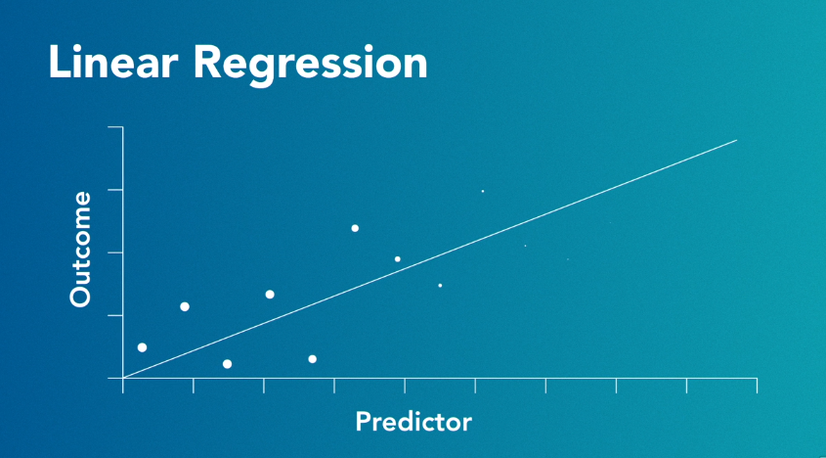

### **Naive Bayes**

Selecting transcript lines in this section will navigate to timestamp in the video

- You've seen that supervised machine learning algorithms can classify your data. Unsupervised machine learning algorithms can cluster your data. Now let's look at an entirely different set of algorithms based on conditional probability. Say you're looking to see how one thing impacts the probability of another thing happening. The most popular algorithm for this type of analysis is called the Bayesian algorithm based on the Bayes' theory of statistics. Naive Bayes is one of the most popular Bayesian machine learning algorithms. It's called naive because it assumes that all of the predictors are independent from one another. Naive Bayes is mostly used for binary or multiclass classification. So let's go back to our animal shelter in Chicago. Imagine that we wanted to classify all the dogs in the shelter based on their different breeds. Remember that there are hundreds of different dog breeds. On top of that, most dogs would be a mixture of several breeds. Let's look at this problem using a naive Bayes machine learning algorithm. To start, let's create three classes of dog breeds. We'll use terrier, hounds, and sport dogs. Now, for each of these classes, we'll have three predictors. Let's use hair length, height, and weight. Remember that some of the predictors will be closely autocorrelated. A tall dog is more likely to be heavier. But naive Bayes considers each one of these predictors independently. Remember, that's why it's called naive. Once you have your classes and predictors set up, then the naive Bayes machine learning algorithm starts with something called class predictor probability. This is when it looks at each of the independent predictors and tries to create a probability that the dog belongs in each class. So let's see what happens when you're trying to identify an unknown dog. The first predictor you look at is hair length. The machine learning algorithm can check the probability of a dog with this hair length belonging to any of the three classes. It finds that a dog with this hair length has a 40% chance of being a terrier, a 10% chance of being a hound, and a 50% chance that it's a sport dog. The next thing you check is the unknown dog's height. Again, naive Bayes doesn't correlate the dog's hair length with the dog's height. It looks at this predictor independently and tries to calculate the probability that this unknown dog will belong to each class. So, again, it looks at the training data and finds that there's a 20% chance that it's a terrier, a 10% chance that it's a hound, and a 70% chance that it's a sport dog. The final thing you want to check is the unknown dog's weight. This might seem like a strange predictor because it's closely related to height. But remember, the naive Bayes is evaluating the probability of each predictor independently. It looks at the training data and finds there's a 10% chance it's a terrier, a 5% chance that it's a hound, and an 85% chance that it's a sport dog. So you now have this table with the unknown dog's class predictor probability. If you look at it, you can see that the dog is probably a hound. But remember, most machine learning problems are dealing with terabytes or even petabytes of dog data and is trying to classify millions of unknown dogs. So to classify your dog, you might want to use something called the weighted multiplication function. Since this is a weighted function, the first thing you want to do is create a weight. It's here you'll decide which one of your predictors is the most predictive. You can pick this weight by looking at the training data. You can also tweak it if it improves your accuracy. Here we'll use a weight of three for hair and two for weight and height. So for the weighted multiplication function, take the predictor and multiply it by your weight. When you add up the predictors for hair length, height, and weight, you can see that the second unknown dog is most likely a sport dog. It's less likely that it's a terrier and very unlikely that it's a hound.

**Conditional Probability**

**Binary or Multi class classification**

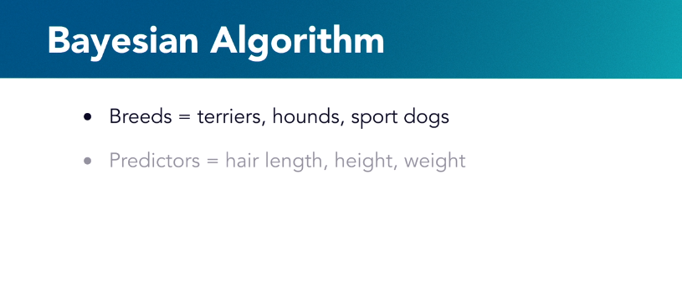

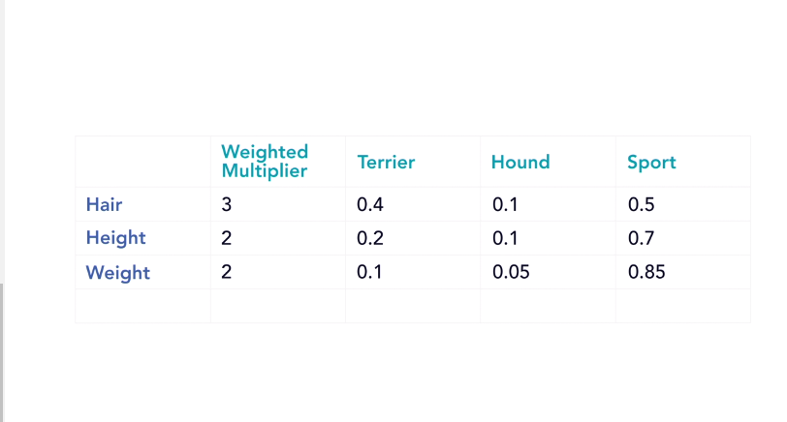

## **Question 1 of 8**

Why is k-nearest neighbor also called lazy learning?

* It is very computationally efficient, and does not do unnecessary work.
* It borrows ideas from several other methods.
* It uses a lot of computation for every instance.  
  Correct  
  It is a brute force matching method.
* It accumulates knowledge very slowly.

## **Question 2 of 8**

What characterizes an outlier in cluster analysis?

* hopping from one centroid to another
* being close to several centroids
* falling exactly on one of the centroids
* not being close to any centroid  
  Correct  
  The outlier is forced into the nearest cluster, even though it is not a good fit.

## **Question 3 of 8**

Why are dog weight and height not necessarily good choices for predictors in naïve Bayes methods?

* They are independent of one another.  
  Incorrect  
  A heavy dog is likely to be a tall dog.
* They are correlated.
* They are measured in different units.  
  Incorrect  
  The units of a predictor is a scaling issue, not one of naivety.



Replay

Review this video

Naive Bayes

4m 40s

## **Question 4 of 8**

Why are regression methods not considered good examples of machine learning?

* They use plots instead of calculations.
* They are based on algebraic models.  
  Incorrect  
  Regression can use nonlinear models.
* They are based on statistical predictions.  
  Correct  
  Linear regression is an established statistical method.
* They use trend lines.  
  Incorrect  
  Trends can be useful forms of data analysis.

## **Question 5 of 8**

What should you do if your decision tree has too much entropy?

* Delete the leaves.  
  Incorrect  
  This is not the best approach, as you may need the leaves to get to the outcomes.
* Choose a different root.  
  Incorrect  
  This approach may be helpful in streamlining the tree, but it is not necessarily sufficient.
* Add more outcomes.
* Add or substitute predictors.  
  Correct  
  One or more of the predictors is not acting efficiently.

## **Question 6 of 8**

Which one of the following do you use when you look for trends instead of trying to classify data into different groups?

* binary classification
* regression problems  
  Correct  
  These problems tend to have a continuous solution thus you look for trends.
* multiclass classification
* unsupervised learning

## **Question 7 of 8**

Salim wants to predict the best harvest date for his orchard based on prior weather reports and harvest histories. Which type of tool does he require?

* multiclass classification
* binary classification
* regression analysis  
  Correct  
  There are nearly continuous ranges of variables involved.
* transduction analysis

## **Question 8 of 8**

Which of the following is instance-based (or lazy learning)?

* K-NN and Naïve Bayes
* K-Means Clustering and K-NN  
  Correct  
  K-Means Clustering and K-NN are lazy learning. You get all the answers in one big splash.
* K-NN and Regression
* K-Means Clustering and Regression

### **Follow the data**

Selecting transcript lines in this section will navigate to timestamp in the video

- In the movie, All The President's Men, the top informant of the Nixon scandal met in a dark parking garage and told the reporter to follow the money. Only by following the money could the reporter find the truth. I'm reminded of this phrase when I think about machine learning algorithms, except instead of following the money you have to follow the data. But that's easier said than done. In fact, one of the biggest challenges in machine learning is figuring out if your data model has a bias or a variance. Bias and variance are related but they're still two separate challenges. Bias is the gap between your predicted value and the actual outcome. Variance is when your predicted values are scattered all over the place. You can have a high bias and a low variance. In that case, your predictions are consistently wrong. But even worse, you can have a high bias and a high variance. That's when you're consistently wrong but in a very inconsistent way. Think of it this way. A few months ago I went with my son to visit his summer camp. Over the course of a long weekend they tried to give the parents a taste of the campers' experience. The very first morning our son took us to the archery range to show us how to shoot a bow and arrow. The instructor gave each of us a bow and five arrows. He effortlessly let loose his five arrows, which landed in the center of the target. His target as a good example of low bias and low variance. All five of his arrows were gathered tightly in the center of the bullseye. My wife was the second person to try. She'd never really shot a bow and arrow before but seemed to have a gift for it. She let loose her five arrows and had a satisfying thwack as they landed on the target. Since she was a beginner, she didn't have the tightly grouped arrows in the target. Instead, she had a low bias. That means that her arrows were generally gathered around the bullseye, but she had a high variance. There was one that landed straight in the bullseye and the other four were gathered in the next circle. I was the third person to try. I went to summer camp myself so I knew a little bit about how to shoot a bow and arrow, but I wasn't wearing my glasses so I couldn't really see the target. I shot my five arrows but they had a high bias and a low variance. They were tightly gathered in the upper right hand corner of the target. I'd shot the arrows consistently but I was consistently wrong. My son was the final person to shoot at the target, and he had a difficult time pulling back on the bow. So he had a couple of arrows in the corner of the target, one in the tree behind the target, and another that landed just in front. He had a high bias and a high variance. His arrows were spread around the target and he inconsistently overshot or undershot the mark. A very similar thing happens when you're following the data. You can be like the instructor and consistently hit your target with little variability. You can also be like my wife, who was on the right track but didn't quite have it figured out. With a little bit more refinement, she could have consistently hit the target. Then you had me. I was consistent but I was consistently wrong. That means that I had skill keeping the variability low but I was clearly shooting in the wrong direction. My son had a difficult time pulling back the bow, so his arrows were inconsistent and spread all over the place. Remember that bias and variance are ways of measuring the difference between your prediction and the outcome. They're not right and wrong answers but different dials that you need to improve your predictions. The key thing to keep in mind is that you'll use different techniques based on whether you have too much bias or too much variance. For me, all I needed to do was move my grouping a little bit down to the left. For my wife, she had the right target and all she had to do was refine her predictions and tighten up the group. When you know which challenge you face, you'll be better equipped to tweak your hyper-parameters and make better predictions.

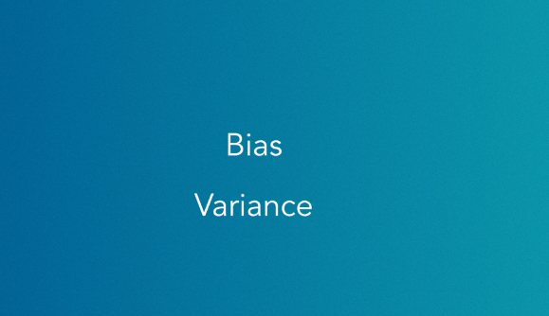

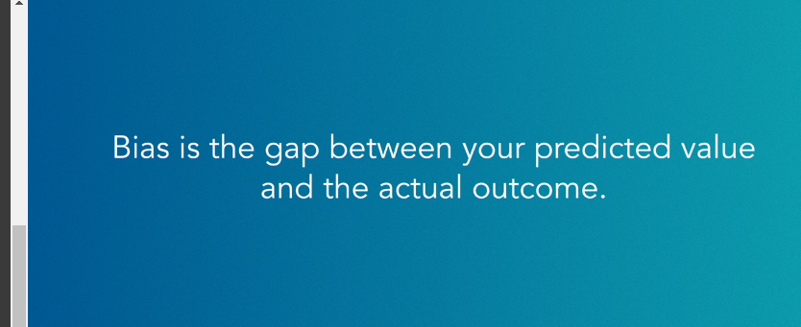

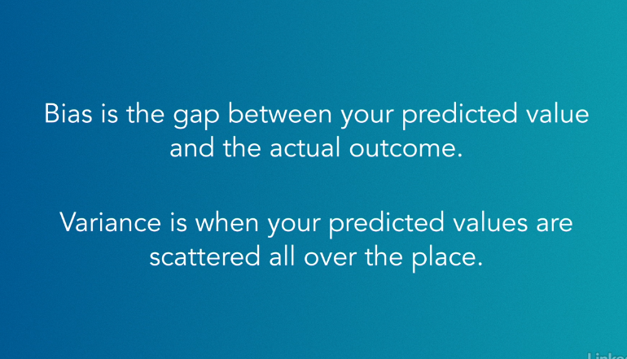

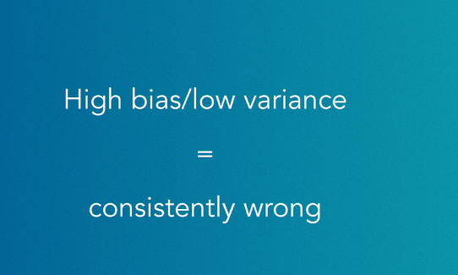

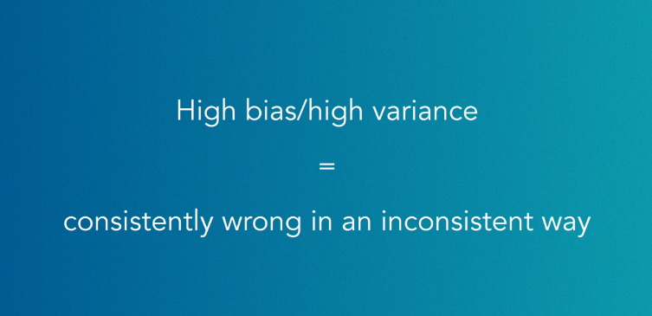

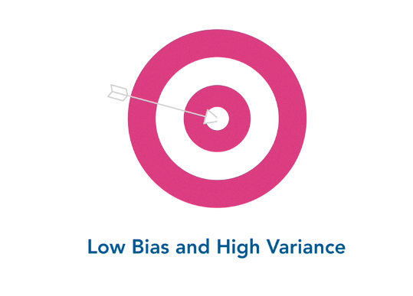

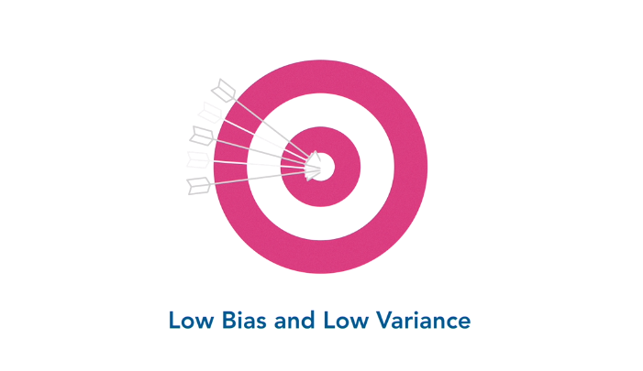

We need >> low bias and lo variance

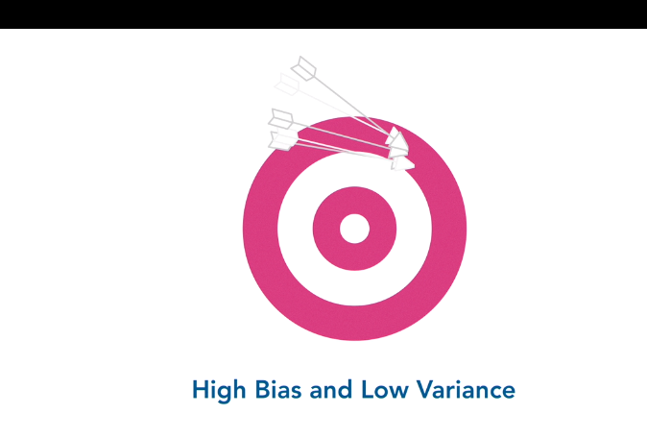

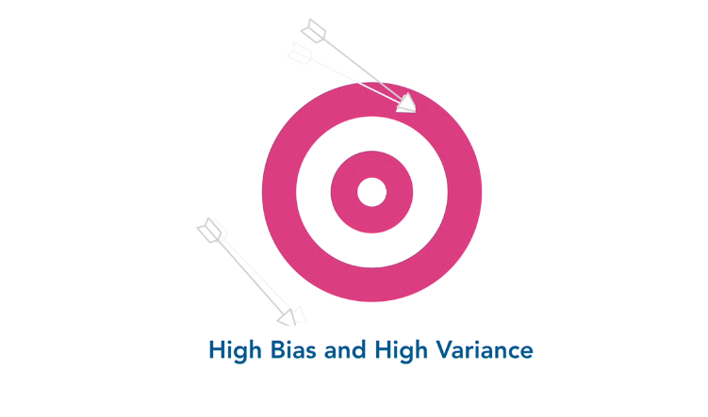

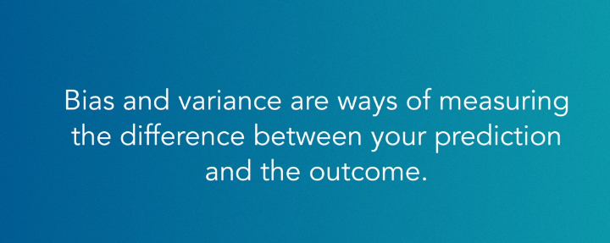

### **Fit the data**

Selecting transcript lines in this section will navigate to timestamp in the video

- In machine learning you'll have to work with a training set. This is a smaller set of the larger data that's used to tune the algorithms. In turn, these algorithms will help you create a model that will work for the larger test dataset. Unfortunately, these training set models can turn out to be a bit of a challenge. You can try to create a simple model. This might work for small training sets but it's inflexible when you're looking at larger data. This is typically called underfitting. On the other hand, you could create a model that's flexible enough to work with the dataset but so complex it's difficult to understand. This is typically called overfitting. Let's think about what this might actually look like. Imagine you work for a website like Zillow that matches up buyers and sellers of houses. You're trying to create a data model that will help your buyers predict the value of their home. To do this you create four main predictors. You use the square footage, the location, number of bathrooms, and the number of bedrooms. You could use supervised machine learning and regression to try and create some trend lines to predict the value. While you're working, you notice that there's a lot of variance in the data. Sometimes this is called noise. That means that there are a lot of houses with very different prices that have the same square footage, the same location, and the same number of bathrooms. To fix this you add more complexity. Maybe you create new predictors such as quality of view, modern appliances, or walkability. Now when you add more complexity you're also making the model more flexible. That's because now there are many more predictors to consider. But you're also making it more difficult to manage. It'll be more difficult to see relationships between modern kitchens, views, and the location. So here you're overfitting the model to the data. On the flip side you might try to keep things simple. You can create a nice regression chart that shows the relationship between the location of the house and the square footage. It would show that there's a close correlation between prices and big houses that are located in nice areas. This model benefits from being pretty simple. You would think that a big house in a nice area is more expensive than a small house in a different area. It would also be easier to visualize. Unfortunately, this model isn't very flexible. You could have a big ugly house in a nice area. You might also have a big house that hasn't been changed in decades. These problems would certainly reflect the value but they wouldn't be captured in this model. In a sense, the houses would have a low variance but a high bias. They may all be clustered in the same place, but that might not be the right place. This is why it's called underfitting. You're underfitting your model to the data. It's not capturing enough information so it's make inaccurate predictions. Sometimes in data science and statistics you'll hear the term signal and noise. Signal is something that you can use to make accurate predictions while the noise might just be natural variances in the data that might not offer any insights. When you're working with machine learning algorithms, the trick is to simply capture as much of the signal as you can while not getting too distracted by the noise in your data.

**Overfitting**

**high variance but a low bias**

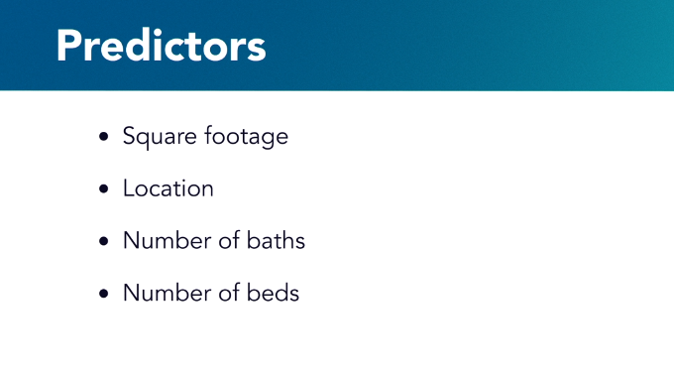

Good on training buy bad on test

***Underfittng***

**low variance but a high bias**

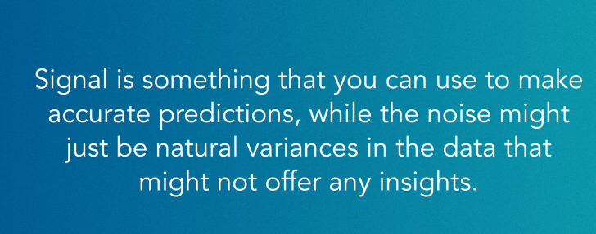

### **Select the best algorithm**

Selecting transcript lines in this section will navigate to timestamp in the video

- Something you'll have to do as a machine learning specialist is pick the best algorithm for your challenge. In some cases you're not going to have much of a choice. If your data is labeled then you're probably going to want to use supervised learning. Remember that labeled data helps you understand both the input and the output. So if you're creating an application that helps you price your home then you'll need a bunch of labeled data. These are usually different tags that help you identify the data. So you'll tag such as zip code, square footage, and number of bathrooms. Your machine doesn't have to find it's own patterns. If your data is unlabeled then you'll probably use unsupervised learning. Here you'll let the machine create it's own clusters. So you'll feed your machine all the data that you have on different homes. Then the machine decides what clusters make the most sense. Maybe the machine clustered together all the homes that have better walkability. It might even be a criteria that's unknown. Once you have the clusters, you'll be able to extract some meaning. If you have massive amounts of unlabeled data you'll probably want to use k-means clustering. Or some other way to have the machines create clusters. On the flip side, if you have a bunch of labeled data then you might want to use regression, k-nearest neighbor or decision trees. You can also try a bunch of different algorithms and then take a closer look at the results. Keep in mind that this can be time consuming and use substantial computing power so don't expect to get results immediately. Let's say that you're working with supervised machine learning, you want to use three different algorithms on your training data, decision trees, naive bayes, or k-nearest neighbor. Then you can look at the results and see which one had the highest level of accuracy. You can also try something called, ensemble modeling. This is when you work to create different ensembles of machine learning algorithms. There's a couple of ways that you can create ensembles. There's bagging, boosting, and stacking. Bagging is when you create several different versions of the machine learning algorithm. Remember that decision trees can be organized in many different ways. You can create many different predictors for the root note. So if you want to use bagging, you would just create several different trees and see which one had the best results. You can also average out the results if you're getting inconsistent outcomes. Boosting is when you use several different machine learning algorithms to try and boost the accuracy of your results. You might use k-means clustering in combination with a decision tree. Here taking the leaves of the tree and then letting the machine decide if there's any interesting grouping. This is also a good example of semi-supervised learning. Stacking is when you use several different machine learning algorithms and stack them to improve the accuracy. The team who won the Netflix prize used a form of stacking. It was called Feature Waited Linear Stacking. They created several different predictive models and then stacked them on top of each other. So you could stack k-nearest neighbor on top of naive bayes. Each one might just add .01% but over time that can be significant improvement. Some winners of machine learning competitions will stack more than 30 algorithms. The key thing to remember it that you can think of each machine learning algorithm as a potential tool. You can experiment to find the best one or you can work with several different tools as a way to improve your accuracy.

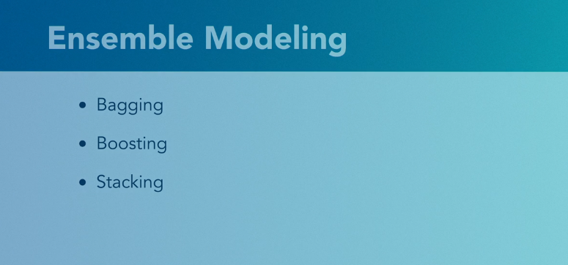

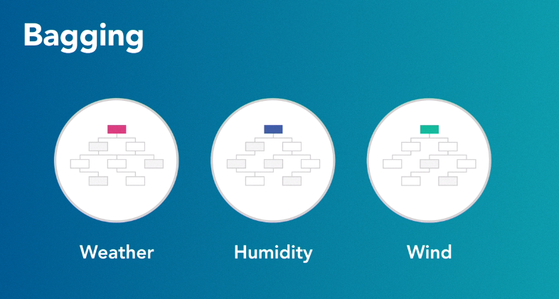

Different version of models eg changing the root nodes

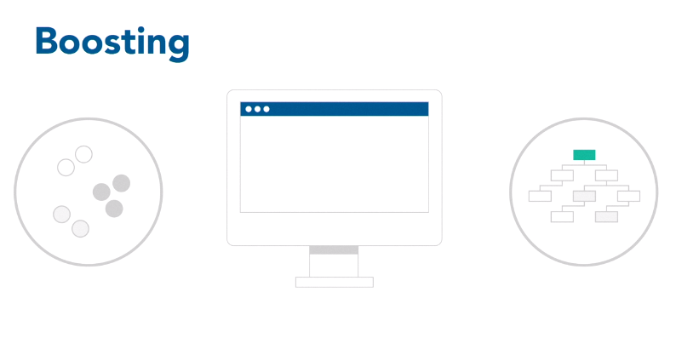

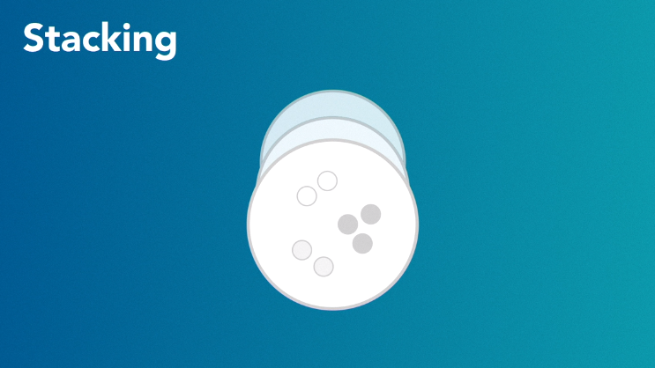

## **Question 1 of 3**

Which scenario is an example of high bias and low variance?

* predictions that are almost always 7.5 pounds too high  
  Correct  
  The predictions are consistently high.
* predictions that are correct on average, but are widely scattered
* predictions that are sometimes a little too high and sometimes extremely low
* predictions that are usually correct

## **Question 2 of 3**

Hugo's modeling strategy uses k-nearest neighbor, followed by regression analysis. What does his strategy exemplify?

* decision trees
* stacking or boosting  
  Correct  
  These are ensemble techniques using methods in series.
* bagging
* unsupervised learning

## **Question 3 of 3**

Lydia has produced a model with 100 predictors that is capable of almost perfectly fitting the 200 observations in the training data. How would you improve Lydia's model?

* by adding more predictors
* by reducing its complexity  
  Correct  
  Using 100 predictors is perhaps too complex.
* by correcting the bias
* by reducing the variance

### **Machine learning challenges**

Selecting transcript lines in this section will navigate to timestamp in the video

- As you can imagine, machine learning is filled with many technical challenges. You can watch for these three common challenges when you're working on your machine learning team. The first challenge is making sure that people in your organization can ask interesting questions. Next is to keep training data separate from testing data. The final challenge is to not spend too much time choosing the right algorithm. Many machine learning specialists work in larger organizations. These organizations will have groups of people with many different skills. It might be difficult to make a connection between the needs of the business and machine learning. Many departments might not have the skills in place to ask interesting questions. So one of your first challenges will be helping the rest of the organization embrace a more exploratory mindset. You might need to push the organization into asking interesting questions. I once worked for an organization that wanted to invest heavily in machine learning. They interviewed at local universities and hired a half a dozen machine learning experts. This team immediately got to work setting up the technology they needed to work with large datasets. Once that was all set up they started to ask people what were the different questions that they wanted to answer. They were just fresh out of graduate school so they were used to running small data experiments and learning from the results. The business people and managers didn't have any experience asking good questions. When they did, it was something like: What type of promotions will our customers like? Which is something that could be solved with traditional database tools. The team felt like they built a Formula One race car and they were showing everyone how to parallel park. That's why you should spend a good deal of time at the beginning working with the business to ask the small, interesting questions. Then once you can ask dozens of good questions, you can work with the business to add greater value. Another challenge you might run into is when teams don't clearly separate training data from the testing data. Remember that training data is the small amount of data that you set aside to build your model in supervised learning. That's where you'll tweak the settings with your machine learning algorithms. Some machine learning teams work to create an extremely accurate model for their training data. Then they show the result to their managers and the rest of the organization. Then they sometimes make the mistake of mixing this training data back into the testing data. When this happens, you'll probably have much less accurate results. The first thing you want to keep in mind is that you should never remix your training and testing data. This makes the data predispose the settings of your algorithm. In a sense, you're already giving your machine the correct answers. Remember that you want your model to be generalizable. That means that it should work well with unfamiliar data. If you're mixing in some of your new data with your old data, you're not really giving your model the fresh perspective it needs to correctly test its accuracy. You also want to watch to make sure you're not overstating the effectiveness of your model. When you present great results with your training data, then it might be confusing to your managers when they same model does poorly later on. The best way to avoid this is to not make presentations with training data. When you make a presentation, make sure that you do it with unfamiliar data. That way your managers have a realistic view of its accuracy. The final thing to keep in mind is that you shouldn't be too concerned if you have a strong bias toward any one machine learning algorithm. Some machine learning experts really like some algorithms better than others. It might just intuitively make sense to them. Some algorithms are just like old songs that bring back pleasant memories. Either way, don't be too concerned about making sure you're selecting the best algorithm. Sometimes you'll work better with your favorite tool than with the newest tool.

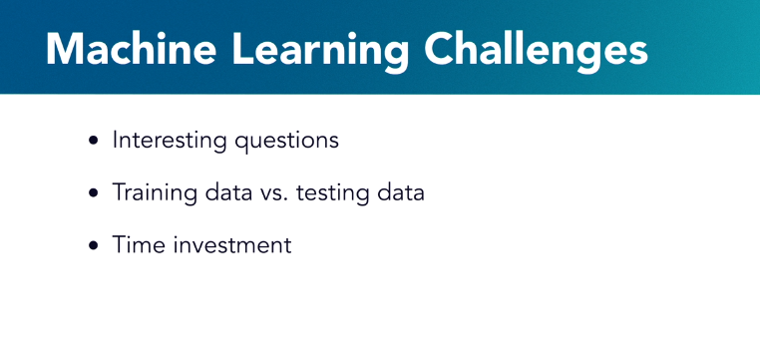

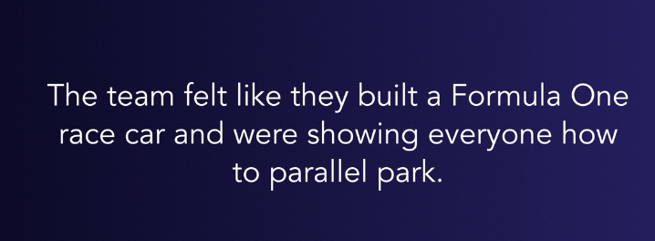



## **Question 1 of 2**

Most of Atul's experience is with decision trees and regression. Which strategy should he embrace as manager of a new project?

* doing a preliminary comparison of all available methods  
  Incorrect  
  This strategy may not be interesting or valuable to Atul's business partners.
* developing expertise in Bayesian and clustering methods
* applying decision trees and regression to the new problem  
  Correct  
  Atul can often make fast progress by exploiting available expertise.

## **Question 2 of 2**

You finished fine-tuning your model with training data, and are eager to show the results to your business team. What should you do instead?

* Show predictions for the testing data.  
  Correct  
  This gives the business team realistic expectations.
* Show a combination of training and testing predictions.  
  Incorrect  
  You should not mix training and testing data.
* Retrain the model using the testing data.
* Show a comparison of predictions for the training and testing data.  
  Incorrect  
  This will lead to confusion and unnecessary questions.
* In _____, you are using _____ to help your program find patterns in _____.
* machine learning; massive datasets; artificial intelligence
* Attempted incorrect option
* artificial intelligence; machine learning; results
* artificial intelligence, machine learning; massive datasets
* Correct answer
* machine learning; artificial intelligence; massive datasets
* Question 2 of 14
* What does the training data, which is a smaller chunk than the test data, help you find?
* inconsistencies
* Attempted correct option
* Patterns ok
* spam
* rules
* Question 3 of 14
* If you are training the machine to predict how long it takes you to drive home, which one of the following is the dependent variable - weather, time of day, holiday, or commute time?
* holiday
* time of day
* weather
* Attempted correct option
* commute time ok
* Question 4 of 14
* What is being optimized in Q-learning?
* the certainty in the results of predictions
* Attempted correct option
* the quality of the outcome or performance ok
* the speed at which training and testing can be completed
* the quantity of data used for training
* Question 5 of 14
* With what type of learning will you need to have access to a lot of data?
* Attempted incorrect option
* supervised
* Correct answer
* unsupervised
* semi-supervised
* tutored
* Question 6 of 14
* What do you call the set environments in Q-learning?
* Attempted correct option
* States ok
* actions
* responses
* quality
* Question 7 of 14
* Joaquim needs a photograph analysis tool to identify the plant species corresponding to individual seeds. Which type of problem does he have?
* Attempted correct option
* multiclass classification ok
* statistical analysis
* binary classification
* regression analysis
* Question 8 of 14
* Which one of the following statements is true?
* Attempted incorrect option
* Learning and improving by trial and error is key to unsupervised learning.
* Multiclass classification is data sorted into several different groups.
* all of these answers
* Correct answer
* One of the key things with unsupervised learning is access to massive amounts of data
* Question 9 of 14
* Decision trees can be used for _____ classification challenges with _____ machine learning.
* regression; supervised
* multiclass; unsupervised
* binary; unsupervised
* Attempted correct option
* binary; supervised ok
* Question 10 of 14
* Which of the following leads to being consistently wrong in an inconsistent way?
* low bias / high variance
* high bias / low variance
* low bias / low variance
* Attempted correct option
* high bias / high variance ok
* Question 11 of 14
* What statement is correct?
* Unsupervised learning classifies the data.
* Predictors are called output variables.
* Supervised learning clusters the data.
* Attempted correct option
* Naïve Bayes is based on conditional probability. ok
* Question 12 of 14
* How do k-means clustering methods differ from k-nearest neighbor methods?
* Nearest neighbor methods require prior centroid identification.
* Clustering methods are only good for binary classification.
* Attempted correct option
* Clustering methods are unsupervised. ok
* Nearest neighbor methods do not require distance calculations.
* Question 13 of 14
* Which of the following is the best fit when you have lots of unlabeled data?
* supervised learning
* decision trees
* K-NN
* Attempted correct option
* K-means clustering ok
* Question 14 of 14

What is the total score for a hound corresponding to the following weights and individual scores?

Multiplier Hound

Hair 3.5 0.8

Height 2.0 0.6

* Weight 1.5 0.4
* Attempted correct option
* 4.6 ok
* 1.8
* 0.6
* 3.8